# Workforce Administration Solution

## Name: Imadabathini Kranthi

## Course: B.tech

## Branch: Artificial Intelligence and Data Science

## Year: 4

## College: Malineni Lakshmaiah Women's Engineering College

### Index

|  |  |  |
| --- | --- | --- |
| **S.no** | **Name of the Topic** | **Page No.** |
| 1 | Requirement Analysis and Planning | 3-7 |
| 2 | Salesforce Development- Backend & Configuration | 7-38 |
| 3 | UI/UX Development & Customization | 39-45 |
| 4 | Data Migration , Testing & Security | 45-48 |
| 5 | Deployment, Documentation & Maintenance | 48-51 |
| 6 | Conclusion | 51-53 |

**1.Requirement Analysis and Planning**

 1.1.   Understanding Business Requirements

**User Needs**

* The HR team requires a centralized system to efficiently manage employee information, project details, assets, asset services, and leave requests, while also generating detailed reports, providing interactive dashboards for workforce insights, and facilitating the organization of meetings.
* Managers require a system that provides clear visibility into which employee is assigned to which project, the type of employment (remote or on-site), employee login and logout times to track working hours, along with comprehensive reports and dashboards for performance monitoring.
* Employees need access to information about project timelines, including the number of days remaining for completion, the ability to submit and track leave requests, view their assigned projects, and stay informed about their allowances (such as cab, Wi-Fi, and food) along with the respective amounts allocated for each.

**Problems Being Solved**

* Eliminates manual paperwork and redundant data entry.
* Automates approval processes and reminders.
* Provides real-time dashboards for workforce insights.
* Enhances data security by restricting sensitive employee information.
* The system should provide detailed reports on assets and project information for each employee.
* The system should prevent the creation of duplicate employee records.

  1.2.    Defining Project Scope and Objectives

**Scope**

➤ Employee Management

* + Centralized repository of employee records (personal, professional, and contact details).
  + Prevention of duplicate employee information through validation rules.

➤ Project Management

* + Tracking of project details, milestones, and timelines.
  + Mapping of employees to projects with visibility for managers.
  + Automated reminders about deadlines and remaining project days.

➤ Asset and Asset Services Management

* + Maintaining a catalog of assets assigned to employees.
  + Tracking of asset services, renewals, and maintenance history.
  + Reports on assets usage by employee and project.

➤ Attendance & Work Tracking

* + Record employee login and logout times to calculate working hours.
  + Differentiate between remote and on-site employees.
  + Provide timesheet reports for HR and managers to analyze workforce productivity.

➤ Leave and Allowance Management

* + Automated leave requests with approval workflows.
  + Real-time leave balance tracking.
  + Tracking of allowances (Cab, Wi-Fi, Food, etc.) and amounts allocated per employee.

➤ Reports & Dashboards

* + Reports for employees, projects, assets, and leaves.
  + Dashboards for HR, Managers, and Employees showing KPIs.
  + Custom filters for department, role, and project-level insights.

➤ Meetings and Collaboration

* + Scheduling and organizing team meetings.
  + Integration with Salesforce Calendar for reminders.
  + Notifications sent to employees about scheduled meetings.

➤ Security and Compliance

* + Role-based access control (HR, Manager, Employee).
  + Field-level security for sensitive information (e.g., salary, personal details).
  + Audit trail to track changes and ensure compliance.

**Objectives:**

➤ Centralized Workforce Data

* + Maintain accurate, up-to-date employee records in a single system.
  + Eliminate duplication of employee data through validation rules.
  + Ensure secure storage of sensitive information.

➤ Project Allocation and Monitoring

* + Assign employees to specific projects with clarity on roles and responsibilities.
  + Track project timelines, milestones, and completion status.
  + Provide employees with visibility into the number of days remaining to complete a project.

➤ Asset and Service Management

* + Track assets allocated to each employee (laptops, devices, etc.).
  + Maintain asset service details such as warranties, renewals, and repairs.
  + Generate reports on asset utilization per employee and project.

➤ Attendance and Work Tracking

* + Record employee login and logout times to calculate working hours.
  + Differentiate between remote and on-site employees.
  + Provide timesheet reports for HR and managers to analyze workforce productivity.

➤ Leave and Allowance Management

* + Automate leave requests with approval workflows involving managers and HR.
  + Provide employees real-time access to leave balances and status.
  + Manage and track employee allowances such as cab, Wi-Fi, and food, along with allocated amounts.

➤ Reports and Dashboards

* + Deliver interactive dashboards for HR, Managers, and Employees.
  + Provide detailed reports on employees, projects, assets, leave, and allowances.
  + Support decision-making with workforce analytics and KPIs.

➤ Meetings and Collaboration

* + Enable scheduling and tracking of team and project meetings.
  + Send automated notifications and reminders to attendees.
  + Ensure integration with Salesforce Calendar for smooth collaboration.

➤ Automation of HR Processes

* + Reduce manual intervention by automating repetitive tasks.
  + Implement Apex triggers and Salesforce Flows for approvals, notifications, and updates.
  + Improve accuracy and efficiency in HR operations.

➤ Security and Compliance

* + Define a role hierarchy for HR, Managers, and Employees.
  + Restrict access to confidential data through profiles, permission sets, and field-level security.
  + Ensure compliance with organizational data policies and audit requirements.

➤ Future Readiness

* + Design the system to be scalable for handling large volumes of data.
  + Keep the architecture flexible to add future features like payroll integration, recruitment, or AI-driven workforce analytics.
  + Ensure mobile compatibility in future phases.

**2. Salesforce Development - Backend & Configuration**

**Salesforce:**

Salesforce is a cloud-based Customer Relationship Management (CRM) platform that enables organizations to manage their sales, service, marketing, and overall business operations from a single, unified system. It provides a wide range of tools and services for automating processes, managing customer data, improving collaboration, and delivering personalized experiences to clients.

Unlike traditional CRM systems that require heavy infrastructure, Salesforce is hosted on the cloud (Software-as-a-Service – SaaS model), making it easily accessible from anywhere through the internet.

**Key Features of Salesforce**   **:**

1. Cloud-based CRM: Accessible from web browsers and mobile devices without installing complex software.
2. Multi-Tenant Architecture: All users share the same infrastructure but have secure and isolated data.
3. Customization: Supports creating custom objects, fields, workflows, and automation tailored to business needs.
4. Integration: Easily integrates with external systems like ERP, email, social media, and payment systems.
5. Scalability: Suitable for startups, mid-size companies, and large enterprises.
6. AppExchange: Marketplace for pre-built apps and solutions that can be installed into Salesforce.
7. Security: Role-based access control, profiles, permission sets, and encryption for data protection.

**Salesforce**   **editions:**

1. Essentials Edition – Basic CRM features for small businesses.
2. Professional Edition – Complete CRM with customization for growing teams.
3. Enterprise Edition – Advanced customization, automation, and integration for large organizations.
4. Unlimited Edition – Full-featured edition with unlimited customization and 24/7 support.
5. Developer Edition – Free edition for developers to build and test applications.

**Salesforce Developer Account Creation:**

I followed the below steps to create my developer Account:

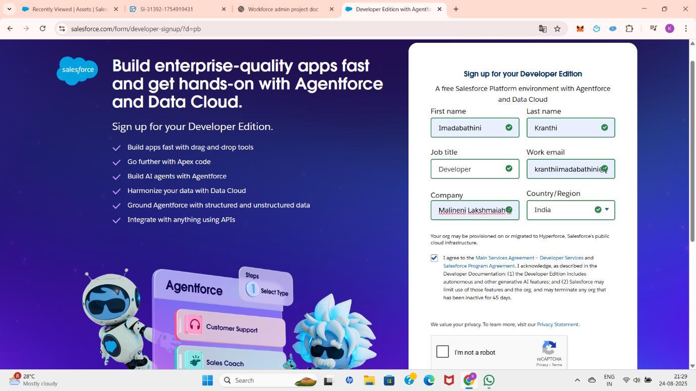

Fill all the details required to create an account:

First Name, Last Name, Job title : Developer, Work email: Personal email, Company, Country

and after that check the given checkboxes by reading all terms and conditions.

After that, you will get a page with your information like this:

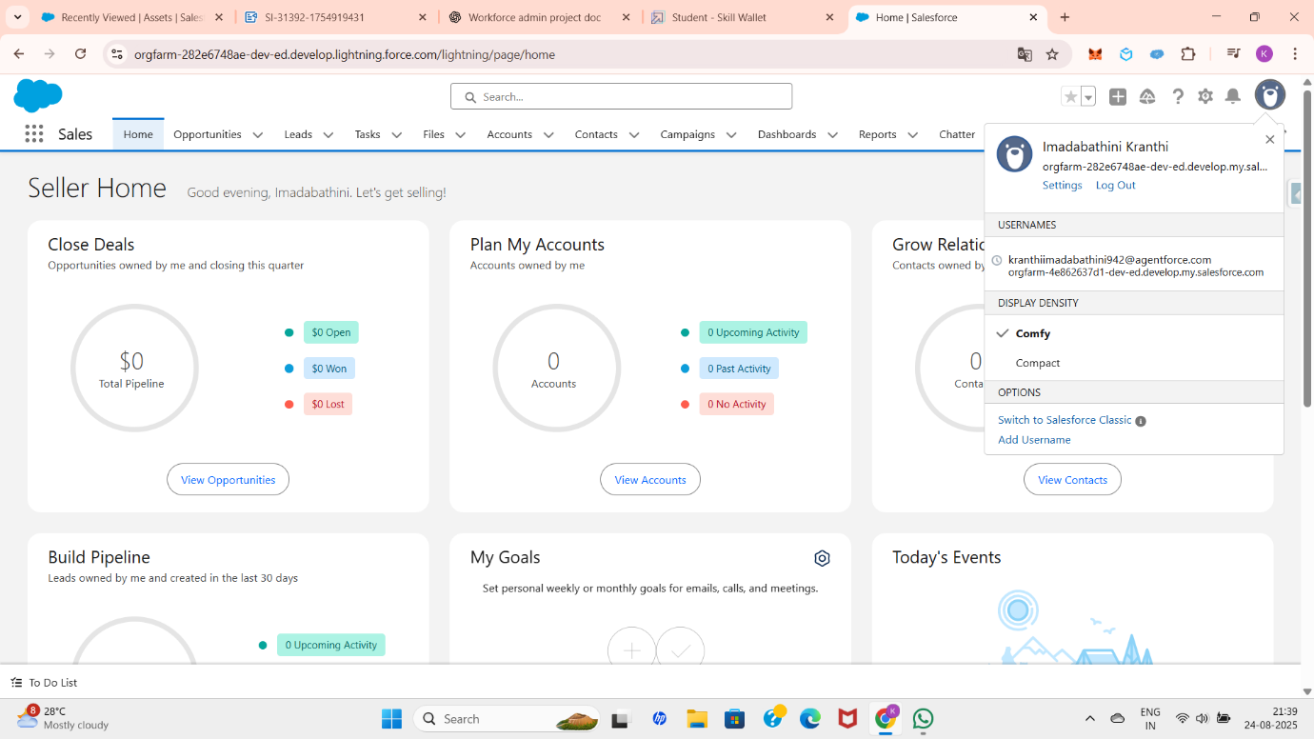

  2.1  Custom Objects , Fields and Relationships

**Objects:**

Objects are database tables that store information specific to an organization. Each object contains a set of fields (columns) and records (rows), similar to how data is stored in a spreadsheet or database.

Objects help businesses model their data, track interactions, and manage operations effectively.

**Types of Salesforce Objects**   **:**

➤ Standard Objects

* + Predefined by Salesforce and available in all editions.
  + Used to handle common business processes like managing accounts, contacts, and opportunities.

➤ Custom Objects

* + Created by users or developers to meet unique business needs.
  + Allow defining custom fields, relationships, and business logic.

➤ External Objects

* + Represent data stored outside Salesforce but accessible within Salesforce using Salesforce Connect.
  + Useful for integrating large external databases without duplicating data.

**Salesforce Standard Objects:**

* Account – Represents a company, customer, or organization.
* Contact – Represents an individual associated with an account.
* Opportunity – Tracks potential revenue-generating deals.
* Lead – Stores information about potential prospects.
* Case – Used for managing customer service issues.
* Campaign – Represents a marketing initiative.
* User – Information about people who use Salesforce.
* Asset – Represents a company’s product owned by a customer.
* Product – Represents items or services sold by the company.
* Contract – Details about agreements with customers.
* Order – Represents requests for products or services.
* Report – Collection of records displayed in a summarized way.
* Dashboard – Visual representation of reports.

**Custom Objects:**

I created an object by using the following Steps:

* Click on the gear icon at the top of the page and select Setup. Next, navigate to Object Manager, then click on Create, and finally choose Custom Object as shown in the figure below.

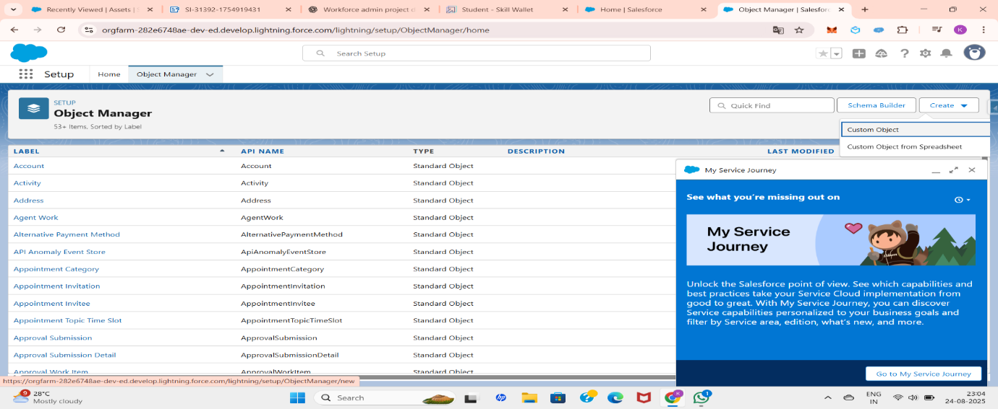

then create the custom object by filling the required fields like below. Here I am creating Asset Object.

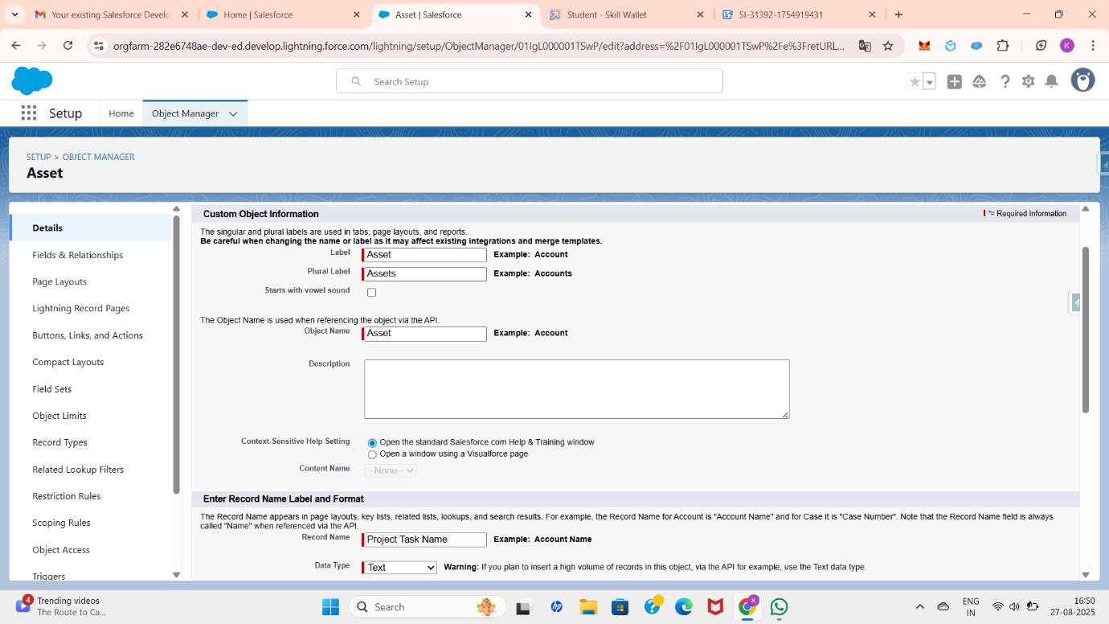

Select the options Allow Search, Allow Reports, and Allow Activities if required for your future uses. After filling in the required details, click on Next, Next, and then Save to create the object. If any mistakes are made during creation, you can search for the object by its name in the Object Manager, edit the details, and save the changes.

Create some other Objects like Asset Service, Project , Employee , ProjectTask.

  2.2 Tabs and Lightning App Development

**Salesforce Tabs:**

In Salesforce, Tabs act as user-friendly navigation links that allow users to access different objects, apps, or web content easily. They are displayed in the navigation bar of Salesforce apps, providing a simple way to interact with data and functionalities.

Tabs make it convenient for users to view records, create new records, and manage object-related information without searching through menus.

**Salesforce Tabs Types:**

➤ Standard Object Tabs

* + Created automatically for Salesforce standard objects such as Accounts, Contacts, Opportunities, Leads, and Cases.
  + Allow users to access records of standard objects directly.

➤ Custom Object Tabs

* + Created for custom objects that you define.
  + Provide easy navigation to the records of business-specific objects.

➤ Visual force Tabs

* + Used to display Visual force pages inside Salesforce as a tab.
  + Helpful for building custom UI functionality.

➤ Lightning Page Tabs

* + Allow Lightning pages to appear as tabs in an app.
  + Enable users to access custom-built Lightning pages .

➤ Web Tabs

* + Used to display an external website or web application inside Salesforce.
  + For example: showing a company’s intranet or help portal.

**Creating Customer Tabs:**

        At first, we need to go to the gear icon and search for tabs in the Quick Find box and select tabs. click on the new button, which is straight to a custom tab.

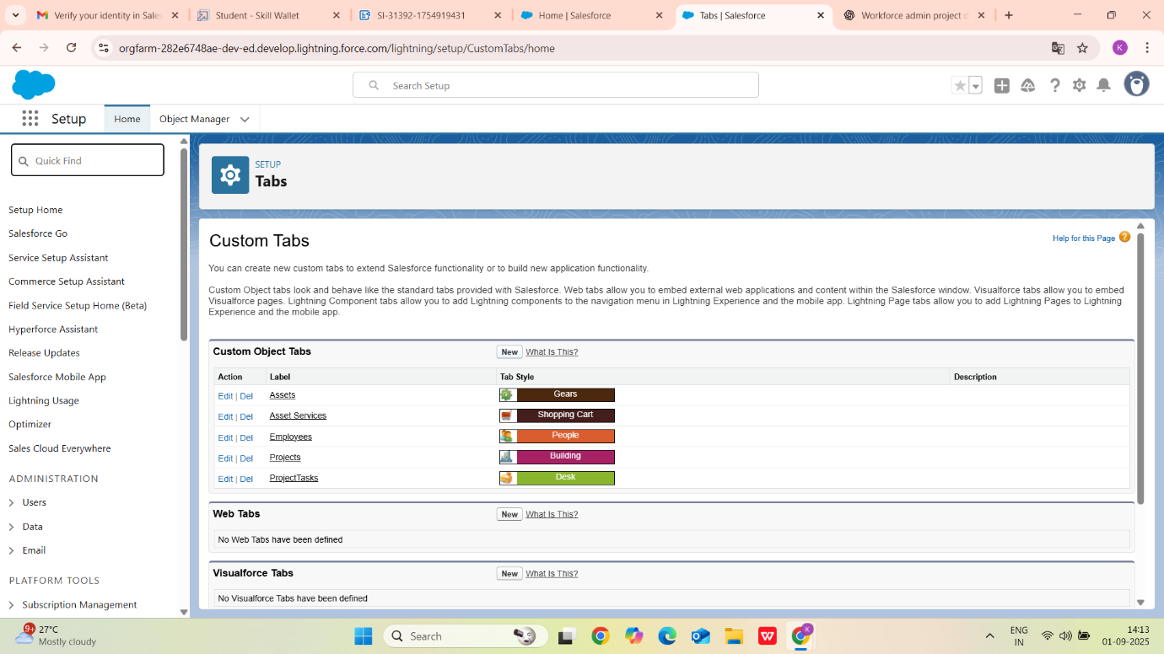

From the drop-down list, select the object type. Choose any tab style and continue clicking Next, next, and next, then click on Save. Your tab will now be created successfully.

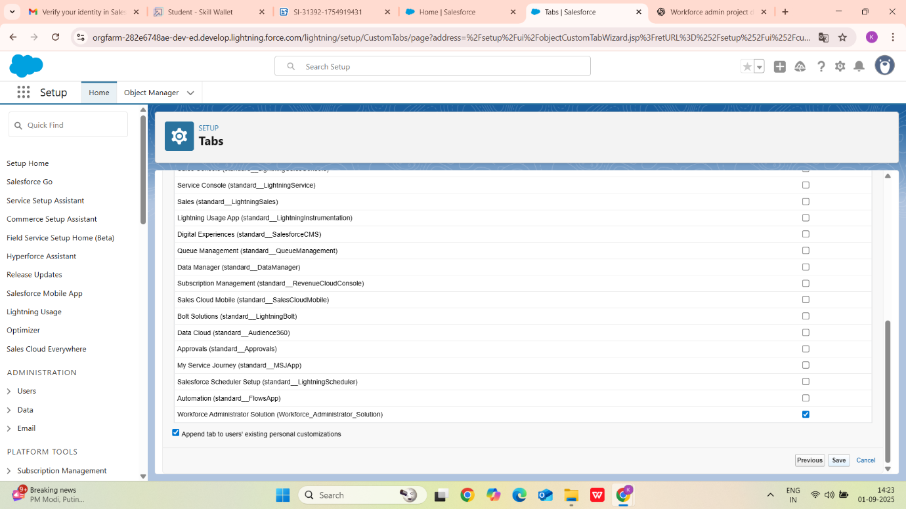

Create tabs for all the custom objects that you have created Just Like in the below image and by following the above steps.

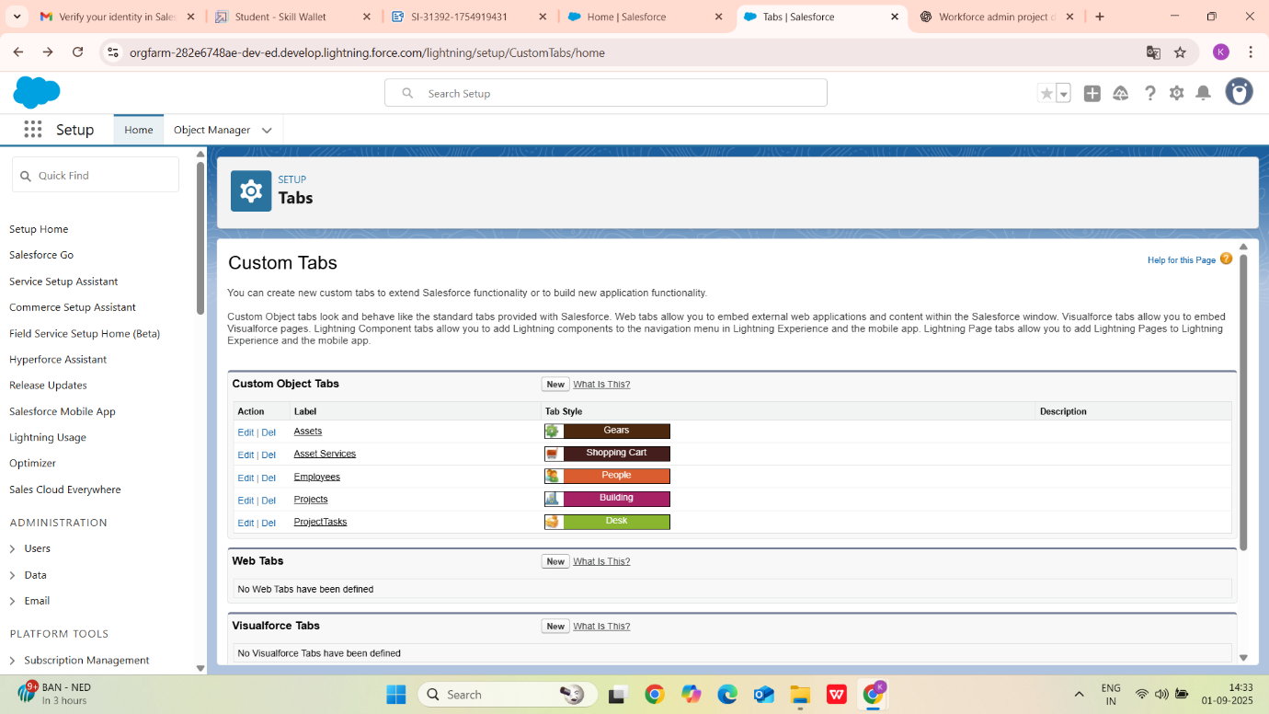

**Lightning App Development:**

A Lightning App in Salesforce is a collection of items such as objects, tabs, utilities, and branding that provide users with a customized workspace. It helps organize related features in one place, making it easier for users to navigate and perform their daily tasks efficiently.

Lightning Apps are built using the Lightning App Builder, where administrators can control the app name, logo, navigation style (standard or console), and the objects or items included.

**Key Features of Lightning Apps**  **:**

* Custom Navigation Bar: Provides quick access to frequently used objects and tabs.
* Branding Options: Allows customization of app logo, color, and label to match business needs.
* Utility Bar: Offers tools such as Notes, History, and custom utilities at the bottom of the app for quick actions.
* Role-Specific Apps: Separate apps can be created for HR, Managers, or Employees with relevant objects and data visibility.
* App Visibility: Apps can be assigned to specific profiles and users, ensuring only the right people have access.

Lightning App Development:

Go to the setup page and search app manager in the quick find box and select it. Click on the new lightning app. Then fill out the details as App Name : Workforce Administrator Solution,Developer Name : this will auto populated, Description : Give a meaningful description,Image : optional (if you want to give any image you can, otherwise not mandatory), Primary color hex value : keep this default

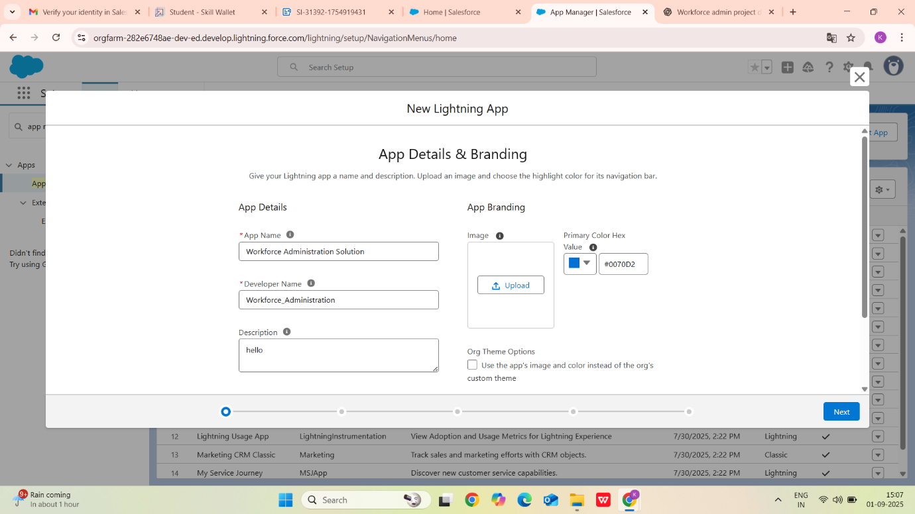

Then click on next, next until the navigation items page. In the navigation items page, click on the right arrow to add items, and the left arrow after selecting the items which you wanted to add in the Lightning App.

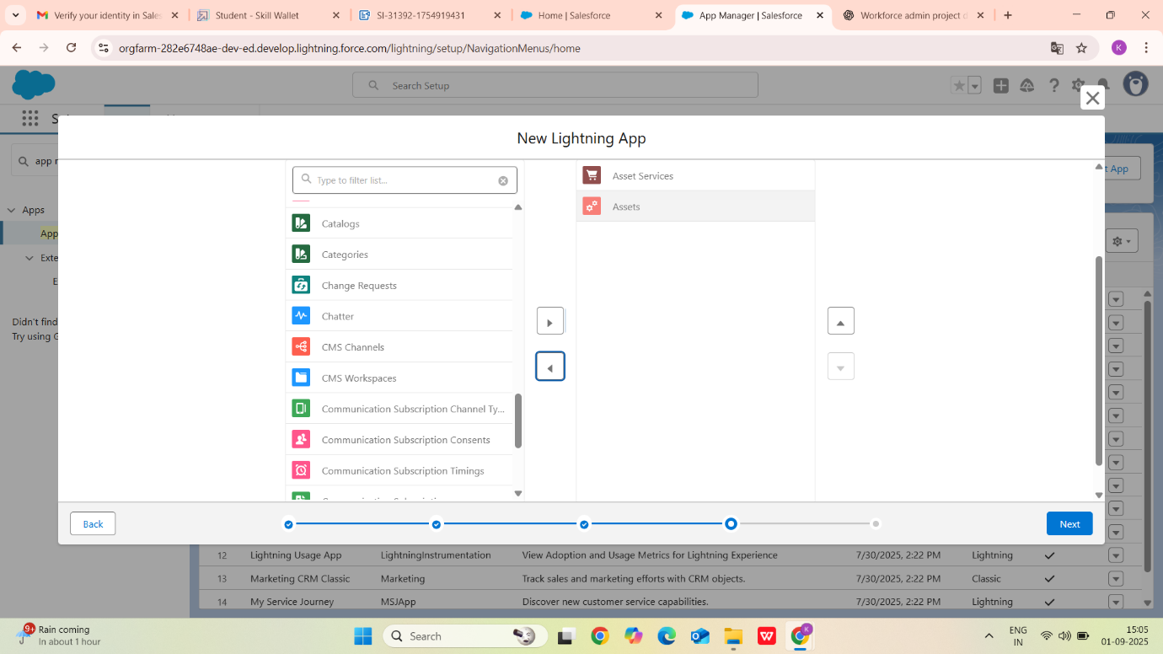

Select user profiles as per the need of the App. Click on save.

  2.3 Organization-Wide Defaults (OWD) and Security Model

**Organizing Wide Defaults:**

Organization-Wide Defaults (OWD) are the baseline security settings in Salesforce that define the default level of access users have to records they do not own. OWD ensures data is protected by restricting access and then opening it up through roles, sharing rules, permission sets, or manual sharing as needed.

It is the foundation of Salesforce’s data security model. By setting OWD, administrators decide whether records should be Private, Public Read Only, or Public Read/Write by default.

**Types of OWD Access**   **:**

Private

* + Only record owners and users above them in the role hierarchy can view or edit the record.
  + Example: Salary or performance details in HR should be private.

  Public Read Only

* + All users can view records, but only the owner or users with higher roles can edit them.
  + Example: Employee directory – everyone can see details, but only HR can update them.

  Public Read/Write

* + All users can view and edit records.
  + Example: Company announcements where all employees can contribute.

  Controlled by Parent

* + The child record’s access is determined by its parent record’s access.
  + Example: A Project Task inherits access from the Project it belongs to.

**Setting OWD:**

Go to Set Up  and  in the Quick Find box type Sharing Settings. click on it.Click Edit in the Organization-Wide Defaults area.Search for the object which you want to create OWD for .

Under default internal access and default external access, change the options to Private, and under grant access using hierarchies, select the check box. Click on save.

Create OWD for all the other objects you wanted to create .

Set the Organization-Wide Defaults (OWD) for all the other objects that you want to create.

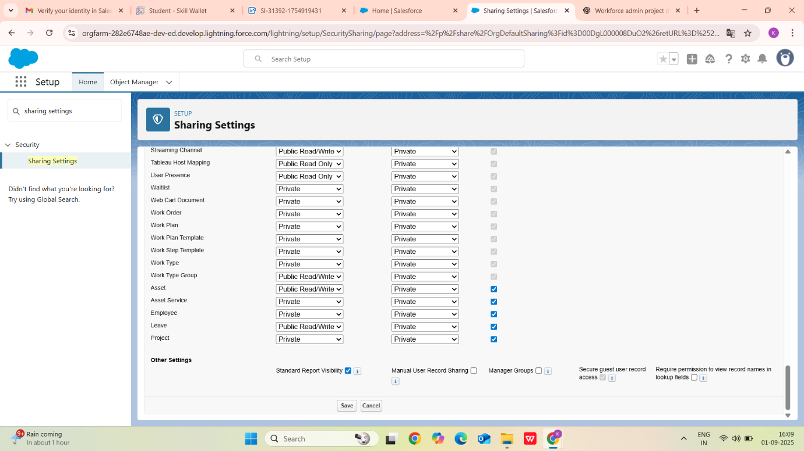

Profile:

A Profile in Salesforce defines a user’s permissions and access settings across the platform. It controls what users can do with objects, fields, tabs, apps, and records. While Roles manage record-level access, Profiles manage object-level and field-level access, ensuring users can only perform actions they are authorized to do.Every Salesforce user must be assigned a Profile, which determines their baseline permissions. Additional permissions can be granted using Permission Sets if needed.

Creating A Profile:

To create a profile, go to **Setup** and in the **Quick Find** box, search for and select **Profiles**.

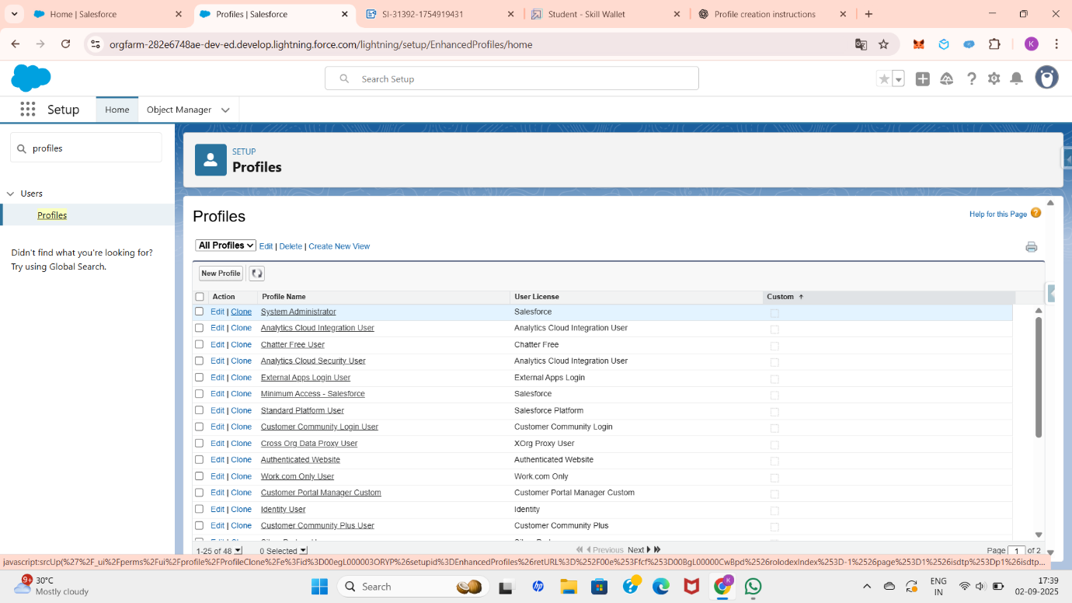

Choose the **Clone** option next to the desired profile. Enter the profile name and click **Save**. On the next page, click **Edit** and assign the necessary permissions required for the profile.

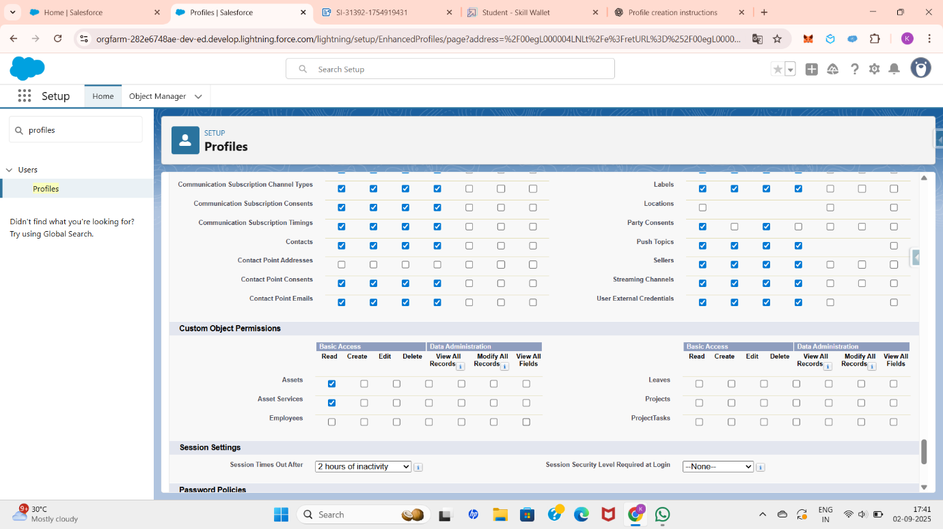

And create some more profiles for some other permissions like the below.

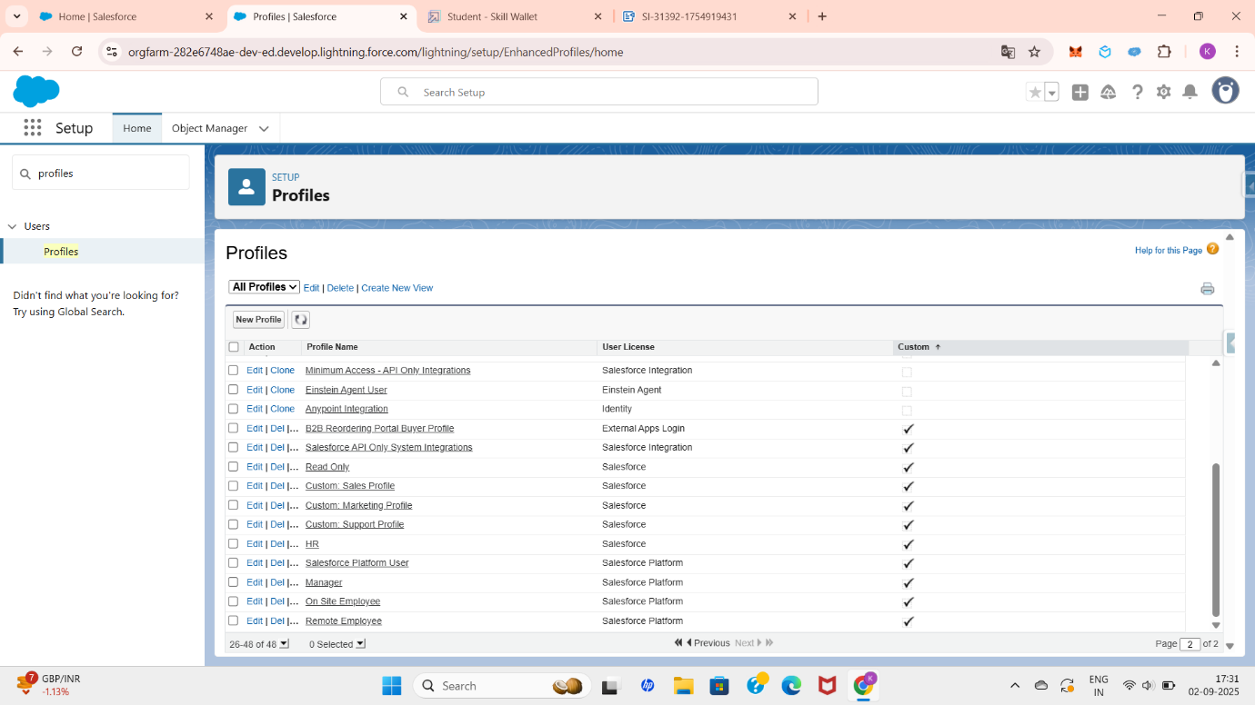

Role:

A Role in Salesforce defines a user’s position in the hierarchy of the organization and determines record-level access to data based on that hierarchy. Roles control visibility to records that users do not own, allowing managers or higher-level users to view and edit records of their subordinates.

Roles work together with Organization-Wide Defaults (OWD) to provide a secure and structured data access model. While OWD sets the baseline access, roles allow data visibility to flow upward in the hierarchy.

Creating a role:

To create a role, go to Setup and search for Roles. Select Roles, then click on Set Up Roles. You can view the existing roles by clicking Expand All. Choose the position where you want to create the new role.

For example, to create an HR role under the CEO, click on Add Role below the CEO role. Fill in all the required details. The Reports To field indicates the parent role under which the new role will be created.

After entering the details, click Save.

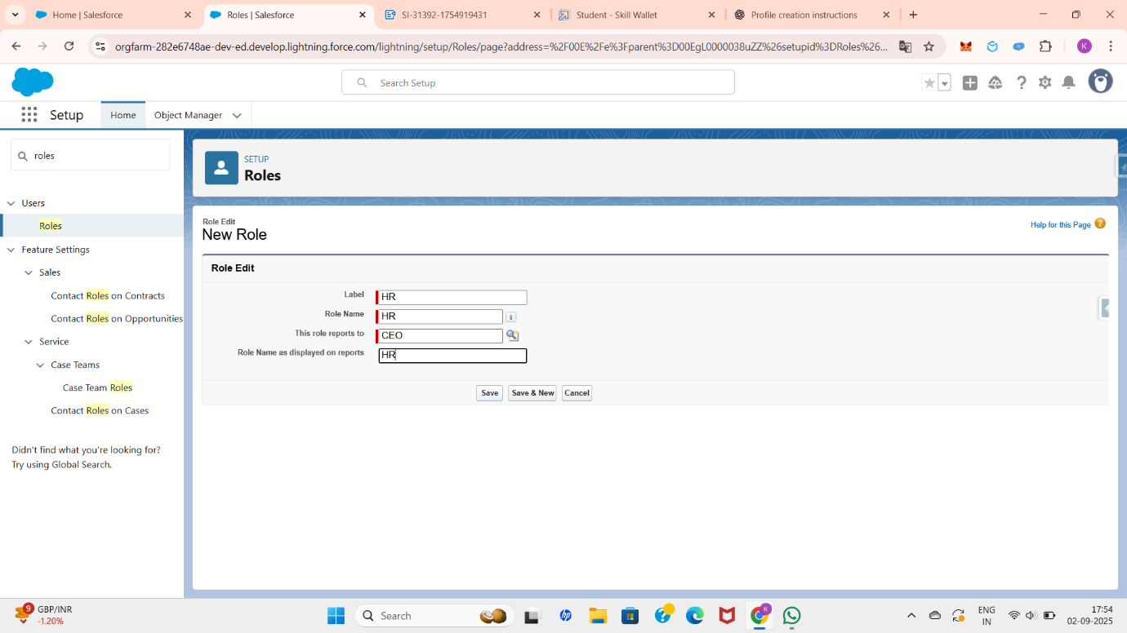

Your new role is now created.

I created some extra roles to share and manage the work. They are On-site Employee(Emp 1), Remote Employee (Emp 2), Manager .

Role Hierarchy:

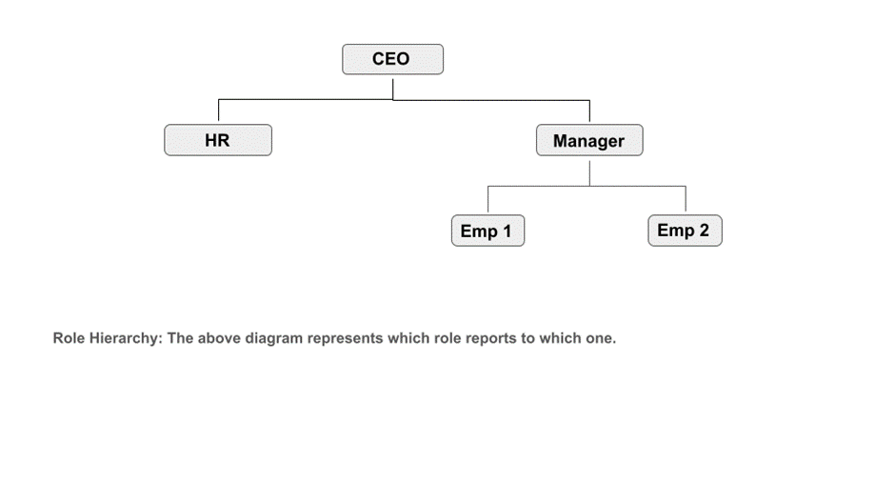Users:

In Salesforce, a User is anyone who has login access to the Salesforce platform. Each user is identified by a User record, which defines their identity, access, and permissions within the system.

A User record in Salesforce contains details such as:

* Username (unique login ID)
* First and Last Name
* Email Address
* Role (defines the user’s place in the role hierarchy)
* Profile (controls what the user can do, e.g., object and field-level permissions)
* License (determines the features available to the user)
* Login details (password, login history, active/inactive status)
* Users = People who log in and work in Salesforce
* Profiles = What they can do
* Roles = What data they can see

User Creation:

To create a user, go to the Setup page, then search for and select Users. Click on New User and fill in all the required details.

* Enter the Username in the format text@text.text.
* Provide your personal email address in the Email field.
* Select the appropriate Role, User License, and Profile based on the permissions you want to assign to the user.

After filling in all the details, click Save.

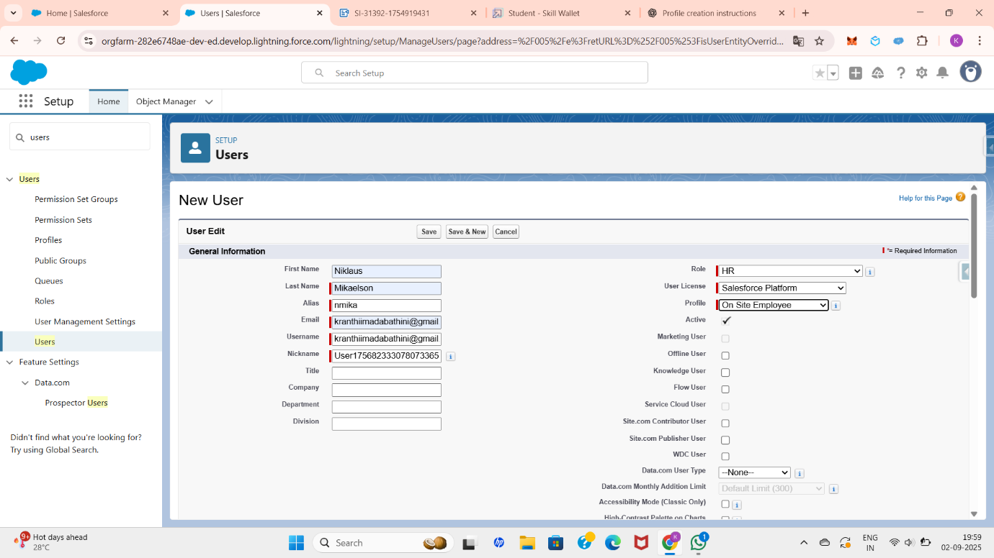

I also created a few more users for the roles I created, like below.

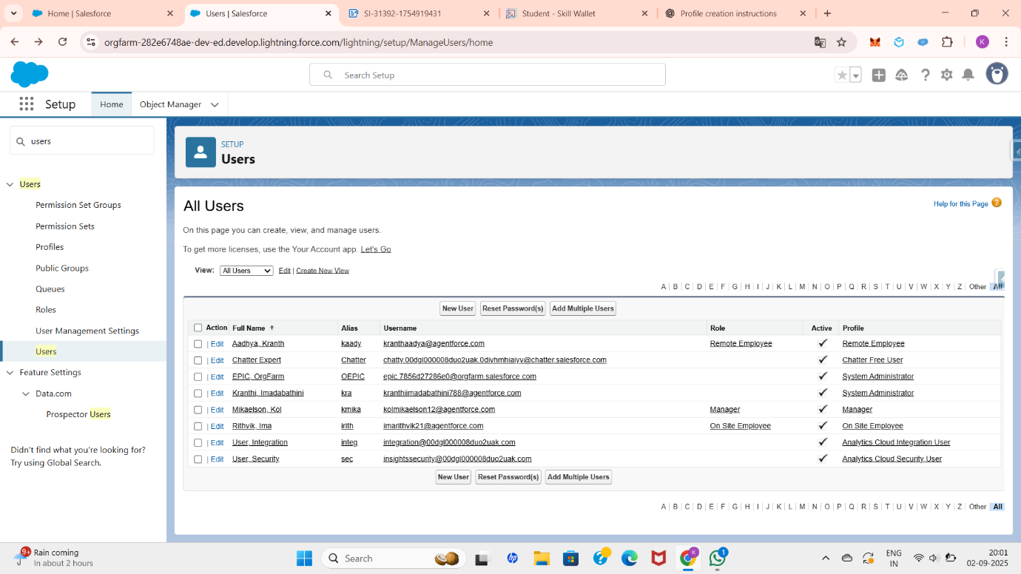

2.4 User Adoption & Collaboration

**User Adoption:**

In Salesforce, **User Adoption** refers to how effectively and consistently users (employees, managers, or stakeholders) embrace and use Salesforce in their daily work. High user adoption means people are regularly logging in, entering data, and leveraging Salesforce features to achieve business goals.

We can perform user management tasks like creating and editing users, resetting passwords, granting permissions, configuring data access, and much more.

**Record:**

In Salesforce, a **Record** is a single, specific entry of data stored in an object — similar to a row in a database or a single entry in a spreadsheet.

**Creating a Record:**

To create a record in this **Workforce Administration Solution** project, first click on the **App Launcher** on the left side. Search for and select the **Workforce Administration Solution** lightning app which we created before, then click on the **Employee** object tab. Next, click on **New** on the left side to create a new record.

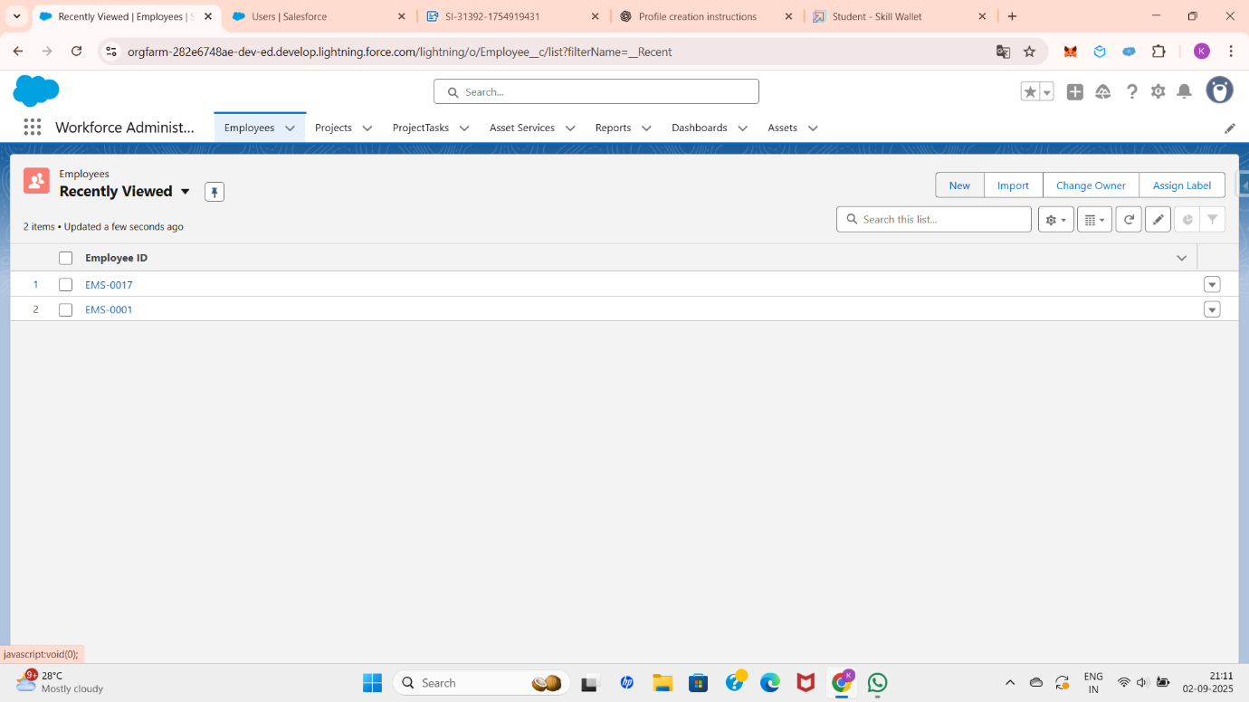

After that, fill in the required details and click **Save**. The record will now be created.

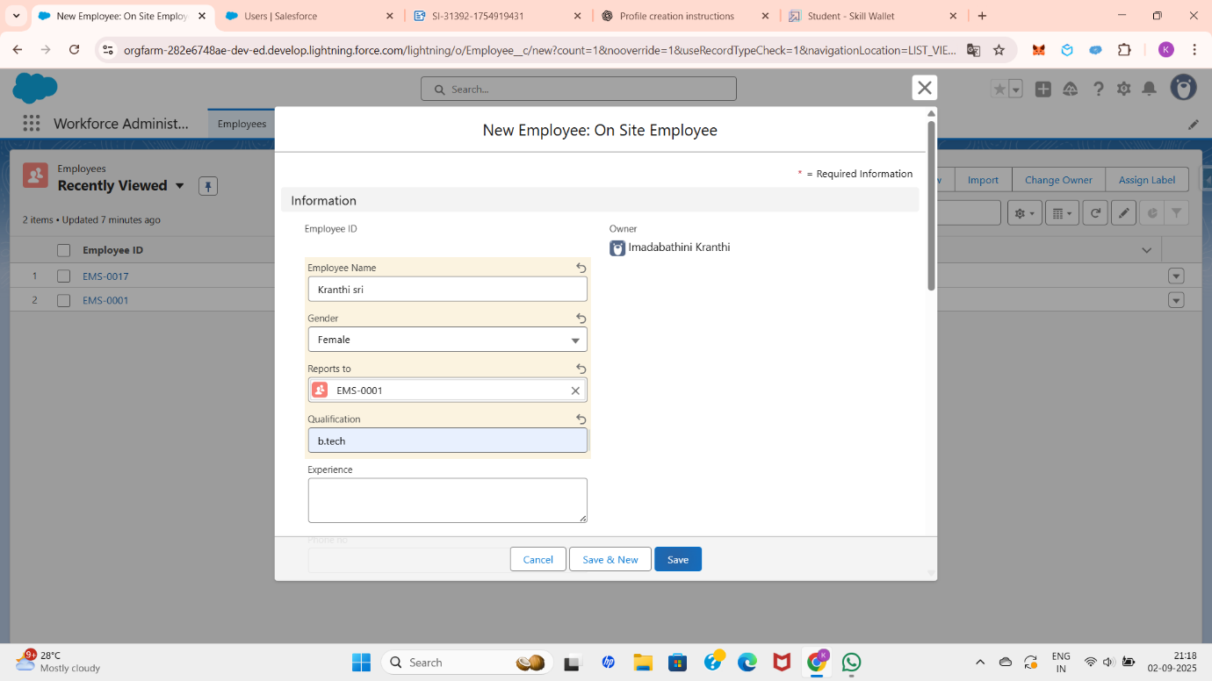

**Viewing a Record:**

To view a record, go to the **App Launcher** and search for **Workforce Administration Solution**. Select it, then click on the **Employee** tab. Choose the name of any record, and you will be able to view its details like below.

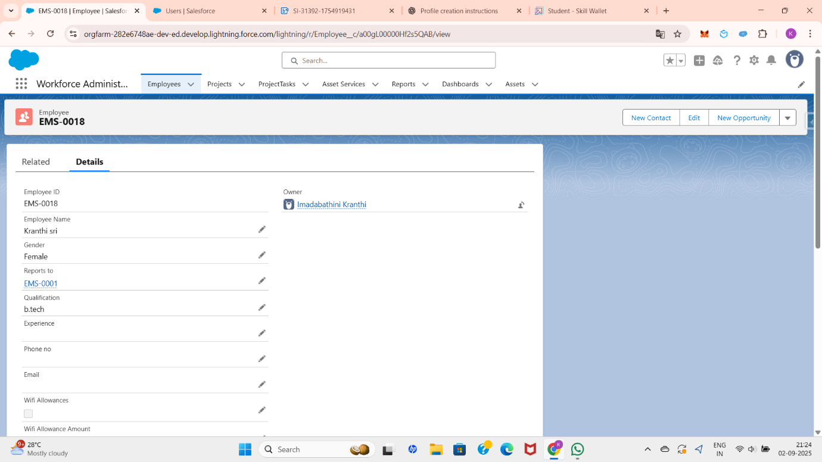

**Deleting a Record:**

To delete a record, go to the **App Launcher** and search for **Workforce Administration Solution**. Select it, then click on the **Employee** tab. Locate the record you want to delete and click on the right arrow next to it. Select **Delete**, and the record will be removed.

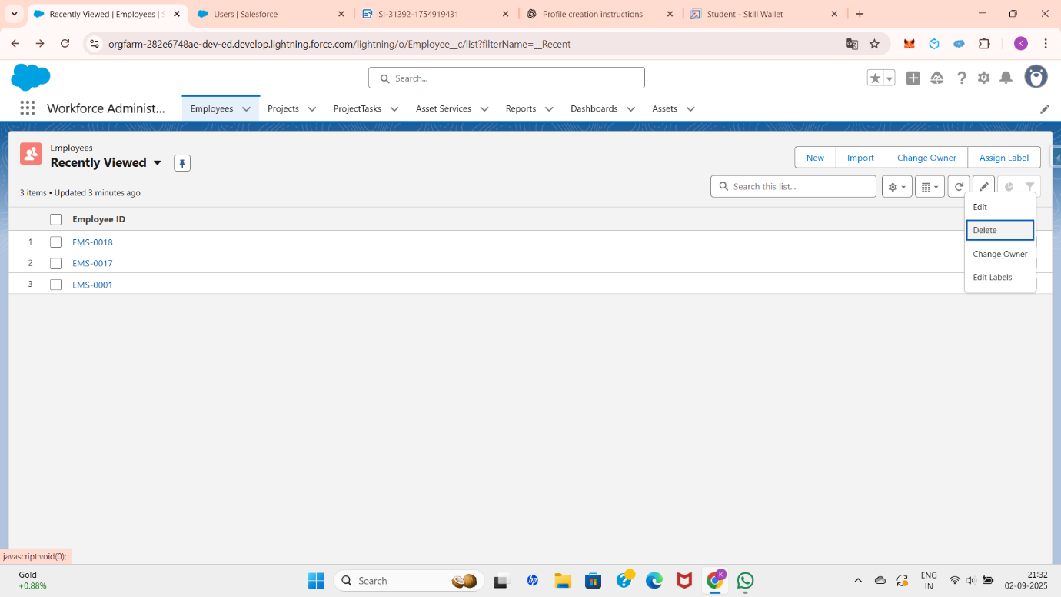

**Chatter Groups:**

In Salesforce, **Chatter Groups** are collaboration spaces where users can communicate, share files, and work together on specific topics, teams, or projects. They help improve teamwork and knowledge sharing within an organization.

Creating Chatter Group:

For creating the chatter group go to app launcher then, search and select groups. Click new which is in right side of the page. Give a group name and a meaningful description. Give access type as private and make sure that allow customers is checked.

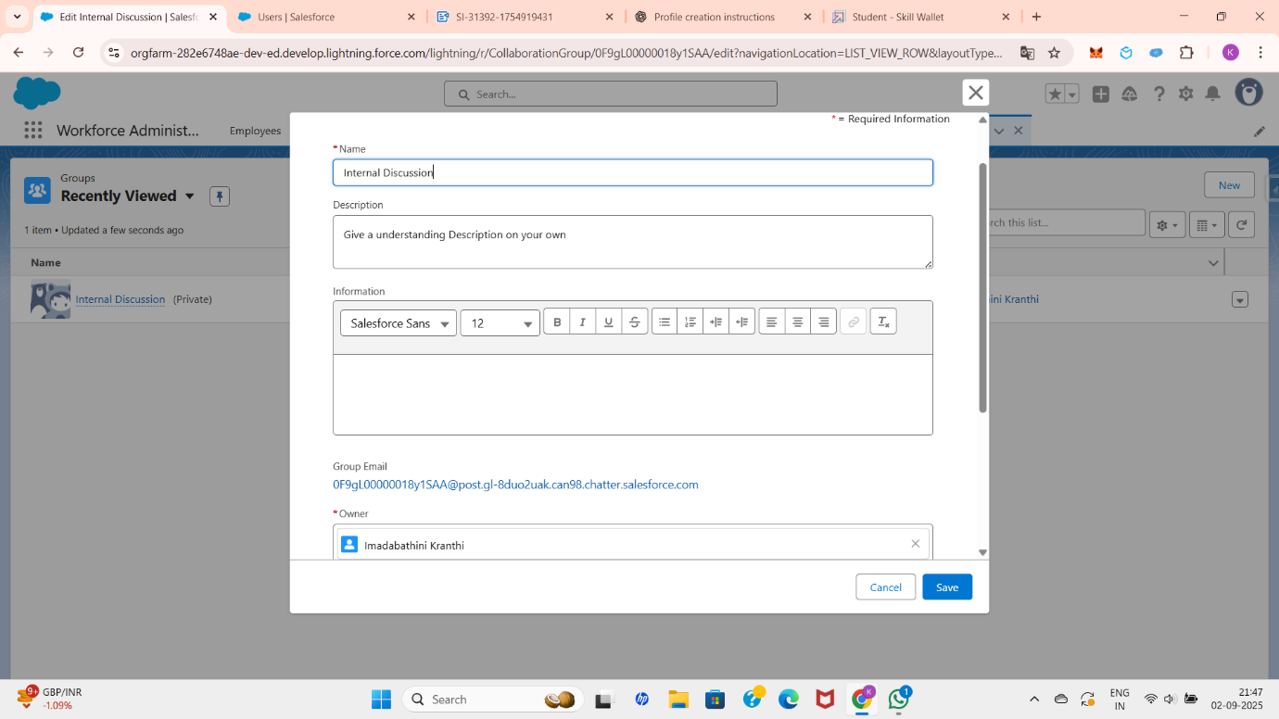

Click on save& next then, ignore upload picture section and click on next. On the manage members screen click Add next to users you created in the previous stage.

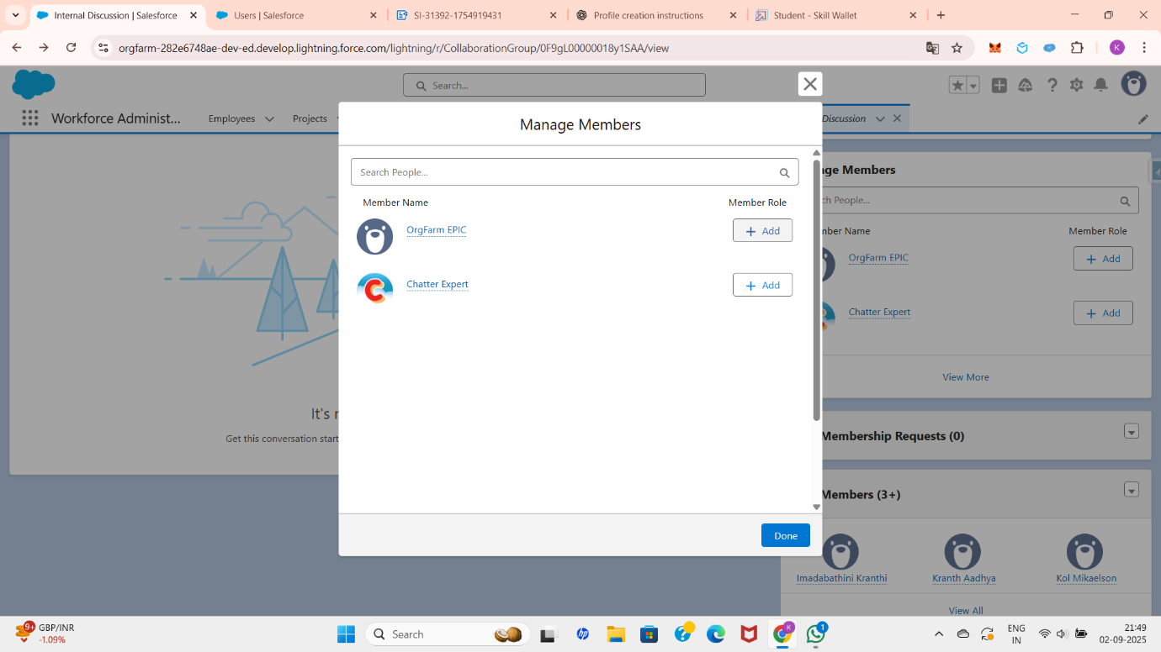

Click on done. The group is created.

It shows like below.

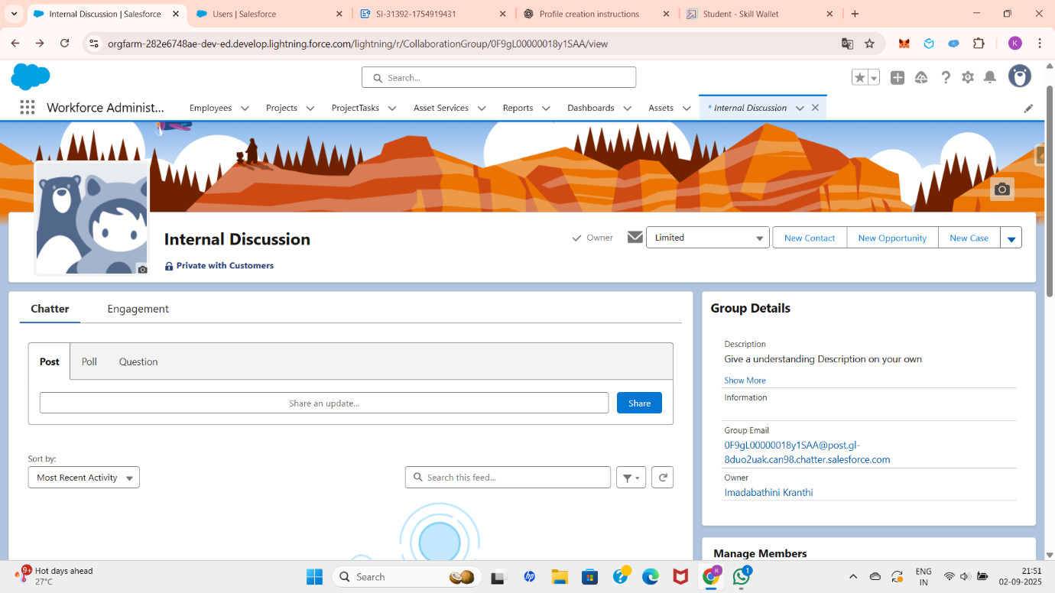

2.5 Record Types, Page Layouts, and Customization

**Page Layouts:** **Page Layouts** control the **organization and visibility of fields, related lists, buttons, and sections** on a record’s detail and edit pages. They define what users see when they open a record and how they interact with it.

**Creating a Page Layout:**

For creating a page layout   go to set up page and click on object manager search for the object which you want to create page layouts for it. From the drop down list of the object click on edit.

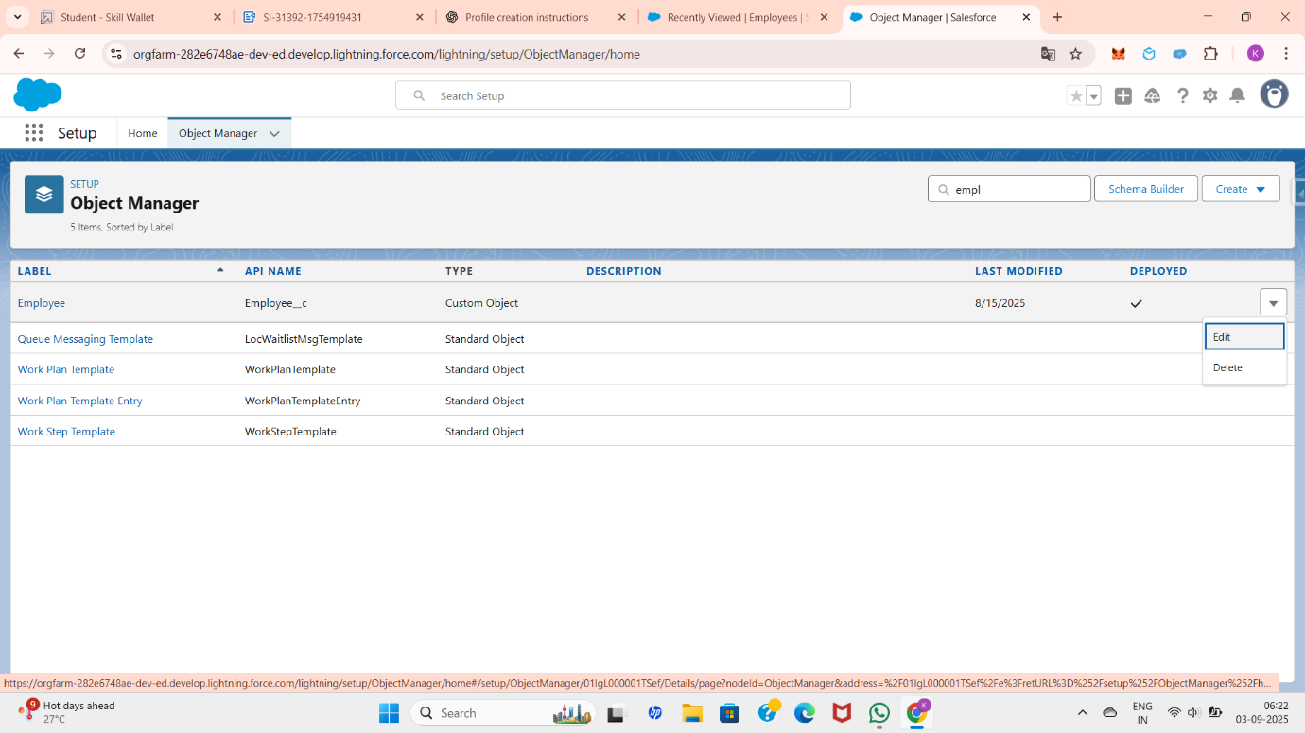

From the left-side panel, select **Page Layouts** and click on **New**.  
Enter a page layout name (for example: On-site Employee) and click **Save**. Next, drag and drop a **Section** from the highlights panel and name it **Personal Information**.

Add the following fields to this section: **Age, Address, and Date of Birth**.Then, drag and drop another **Section** from the highlights panel and add the required fields as shown below.

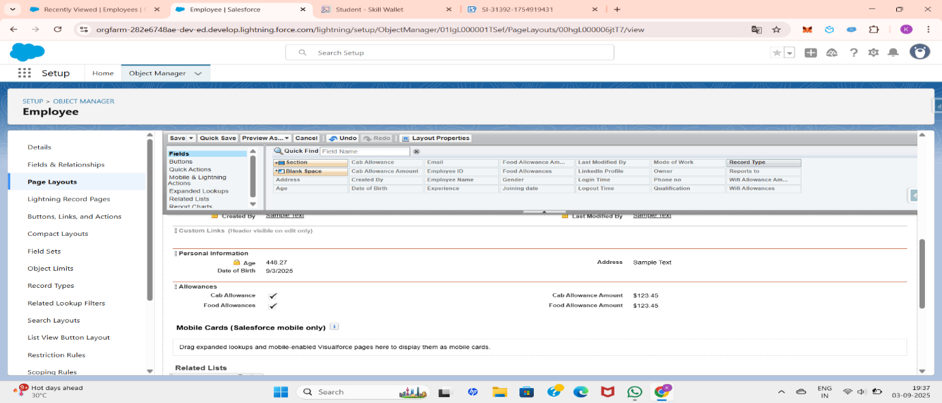

Create another page layout with the name **Remote Employee**.  
Use the same sections created earlier, but add the fields as shown below.

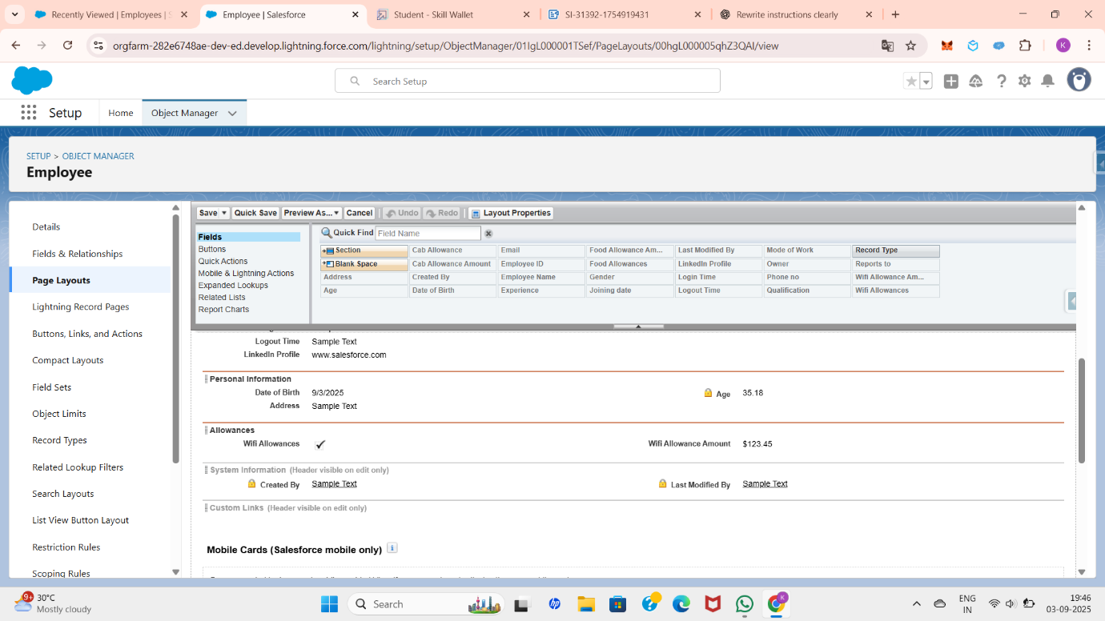

**Record Types:**

**Record Types** are a way to offer different **business processes, picklist values, and page layouts** to different users, based on their profile or role. They help organizations manage variations of the same object for different purposes.

Here I created different forms for employee records based on their mode of work like(on-site or Remote).

**Record Type Creation:**

To create a Record Type, go to the **Setup** page, search for **Employee**, and then click **Edit** from the drop-down list of the Employee object. From the left-hand panel, select **Record Types**.

Click **New**, then enter the **Record Type Label** as On-site Employee. Make it **Active**, and uncheck the option for Make Available.

Scroll down and select the **Manager** and **System Administrator** profiles, then click **Next**. Choose Apply a different layout for each profile and set the page layout to **On-site Employee** for both Manager and System Administrator. Finally, click **Save**.

To create a **Remote Employee** record type, follow the same steps as above, but in the page layout selection, choose Remote Employee instead of On-site Employee.

After creating the Report Types you are able to see them as below.

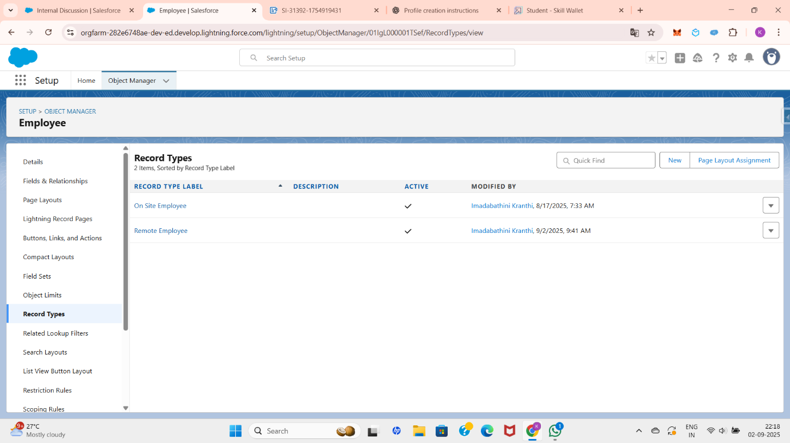

2.6 Data Management and Import

**Data Management:**

Data Management in Salesforce refers to the process of importing, storing, updating, securing, and maintaining data within the Salesforce platform to ensure accuracy, consistency, and accessibility.

**Data import:**

ata Import in Salesforce is the process of **bringing external data (like accounts, contacts, leads, or custom object records) into Salesforce** using built-in tools. It helps organizations migrate or add bulk data without manual entry.

**Importing Data:**

To import data, first prepare an Excel file containing the data in a table format, ensuring that all the required fields are filled.

Next, go to the **Setup** page and click on **Home**. In the **Quick Find** box, search for and select **Data Import Wizard**. Click on **Launch Wizard**, then go to the **Custom Objects** tab and select the desired object.

For example, to import data into the **Employee** object, select it and choose the option **Add New Records**.

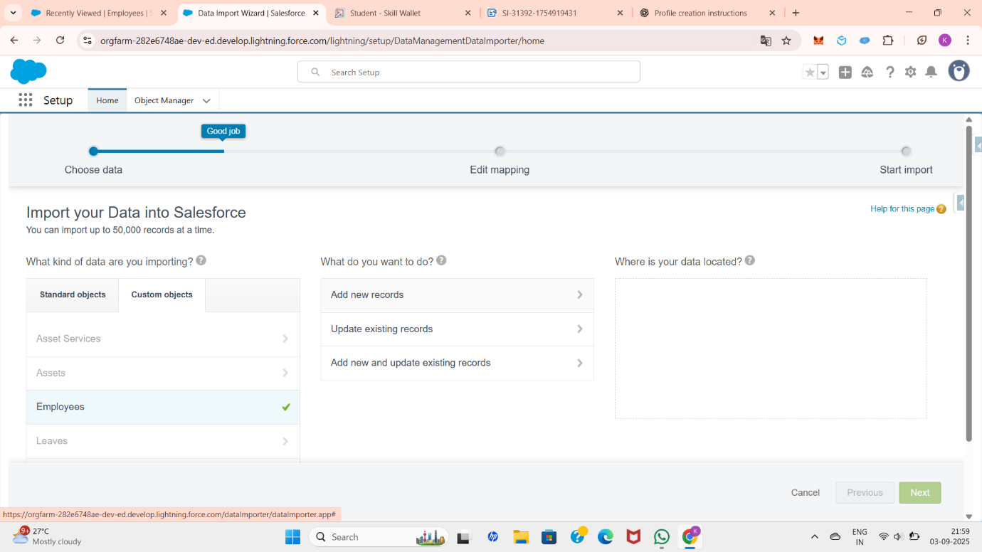

Click on **CSV** and choose the file you created earlier. The fields will be automatically matched. Click **Next**.

On the next screen, a summary of your data import will be displayed. Click **Start Import**, then confirm by clicking **OK** on the pop-up.

Scroll down the page to verify that your data has been imported successfully under the **Batches** section. Make sure the **Records Failed** column shows **0**.

After completing the data import, click on the **App Launcher**, then search for and select **Workforce Administration Solution**. Next, click on the **Employee** tab. From the drop-down list of the Employee object, select **All**. You will now see the new records created from the imported data listed there.

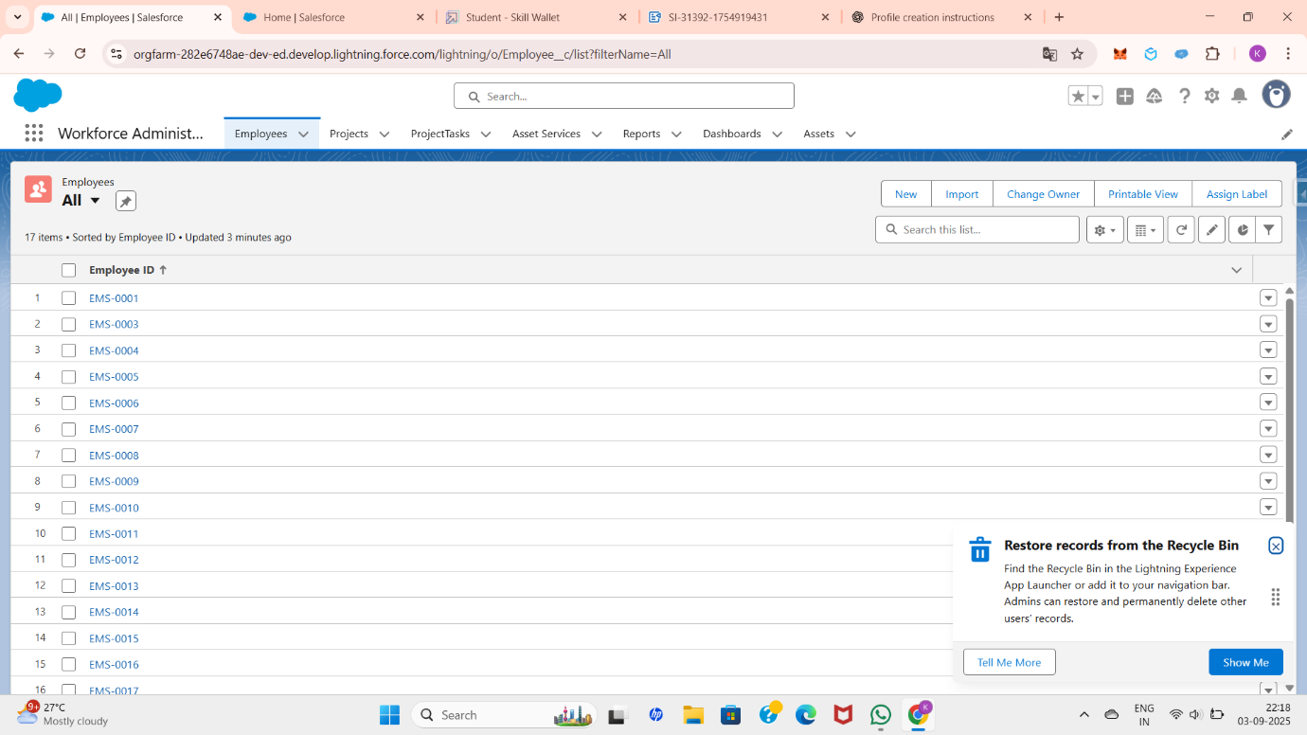

  2.7 Reports and Dashboard

**Reports:**

A **Report** in Salesforce is a list of records that meet certain criteria, displayed in a format you choose. Reports allow users to **analyze data, track performance, and make decisions** based on real-time Salesforce information.

**Key features of reports:**

* **Customizable**: You can filter, group, and sort records to see exactly what you need.
* **Real-Time**: Reports show the most up-to-date Salesforce data.
* **Interactive**: Add charts, summaries, and conditional formatting.
* **Sharable**: Reports can be shared with specific users, groups, or made public.

**Types of Reports:**

➤ **Tabular Report**

* + Simple list of records, like a spreadsheet.
  + Example: List of all Employees.

➤ **Summary Report**

* + Similar to tabular, but allows grouping and subtotals.
  + Example: Employee count grouped by Department.

➤ **Matrix Report**

* + Data summarized in rows and columns (like a pivot table).
  + Example: Employee count grouped by Department and Location.

➤ **Joined Report**

* + Combines data from multiple report types for comparison.
  + Example: Compare Employee details with related Project data.

**Creation of Reports:**

First, go to the **Workforce Administration Solution** app and click on the **Reports** tab. Then, click on **New Report** to start creating a report.

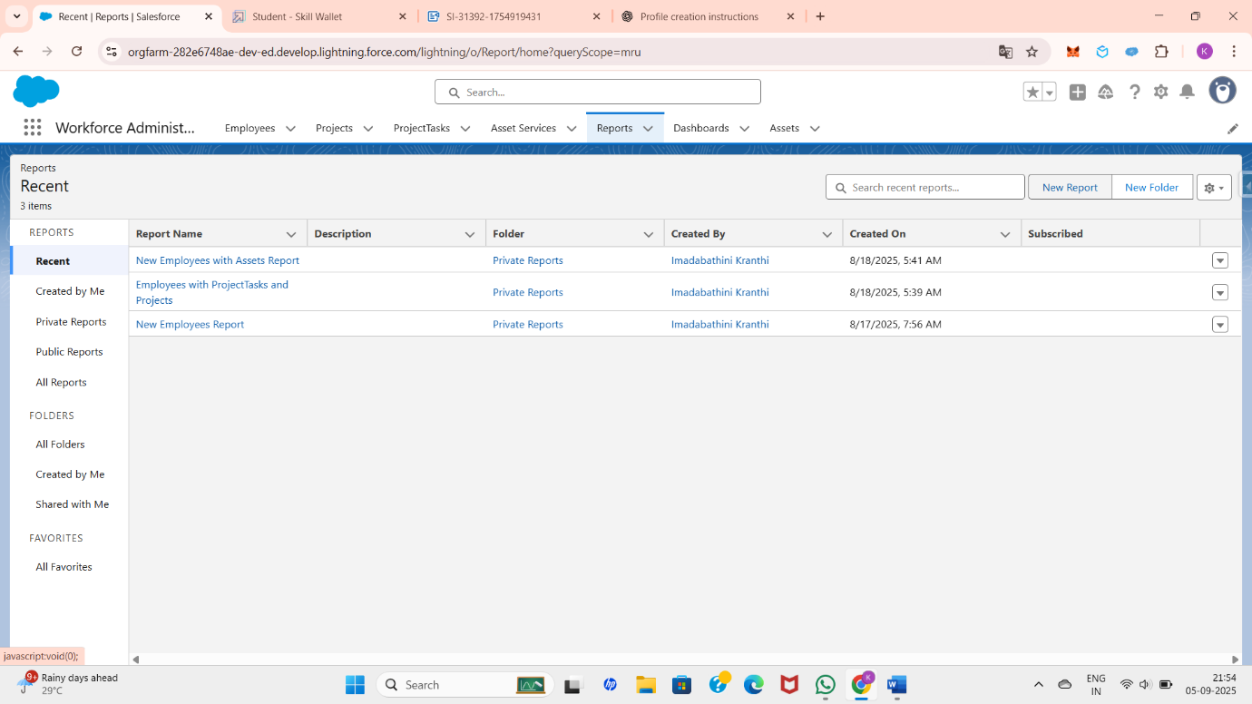

After that, search for the desired report type either from the **Category panel**, the **Report Type panel**, or by using the **Search bar**. Since we are creating an **Employees Report**, select the report type **Employees**, and then click on **Start Report**.

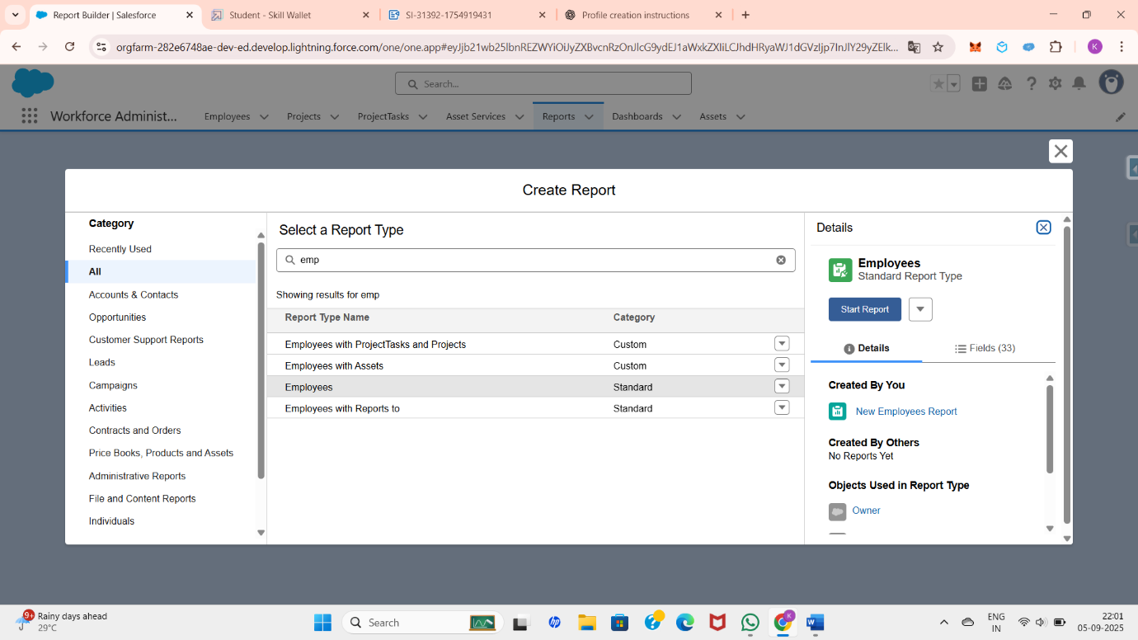

Customize the report by adding additional fields from the **left panel**. Once the customization is complete, click on **Run** or **Save**. After this, the generated report will be displayed.

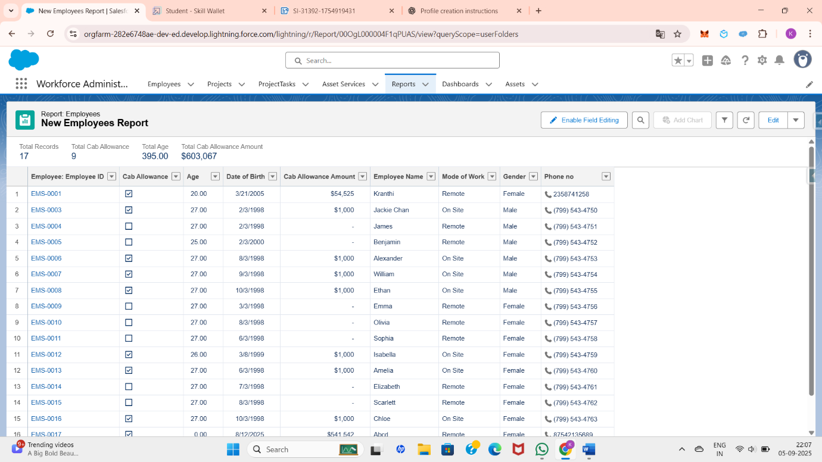

You can also create additional reports based on your requirements. For example, I created two more reports:

1. **Employees with Assets Report** – Displays employees along with the assets assigned to them.
2. **Employees with Project Tasks and Projects Report** – Shows employees along with the projects they are assigned to and the related project tasks.

**Dashboard:**

A **Dashboard** in Salesforce is a **visual representation of reports**. It uses charts, tables, gauges, metrics, and graphs to give users a quick overview of key data and performance indicators in real time.

**Key features of Dashboards:**

* **Multiple Reports in One View**: A dashboard can display data from multiple reports at once.
* **Dynamic & Interactive**: Users can apply filters to see data relevant to them.
* **Real-Time Monitoring**: Displays the most recent data from reports.
* **Visual Formats**: Charts (bar, pie, funnel, line), tables, gauges, and metrics.
* **Customizable**: Admins can build dashboards to suit business needs (team dashboards, executive dashboards, etc.).

**Components of Dashboard:**

* **Chart** – Bar, pie, line, donut, etc.
* **Gauge** – Displays progress toward a goal.
* **Metric** – Shows a single key value.
* **Table** – Displays detailed data in tabular format.

**creation of Dashboard:**

Go to the **Workforce Administration Solution** app and click on the **Dashboards** tab. Click on **New Dashboard**, enter a name, and then click **Create**.

Next, select **Add Component**, choose a report, and click **Select**. Then, click **Add**, followed by **Save**, and finally click **Done** to complete the dashboard creation. The dashboard will appear as shown in the following picture.

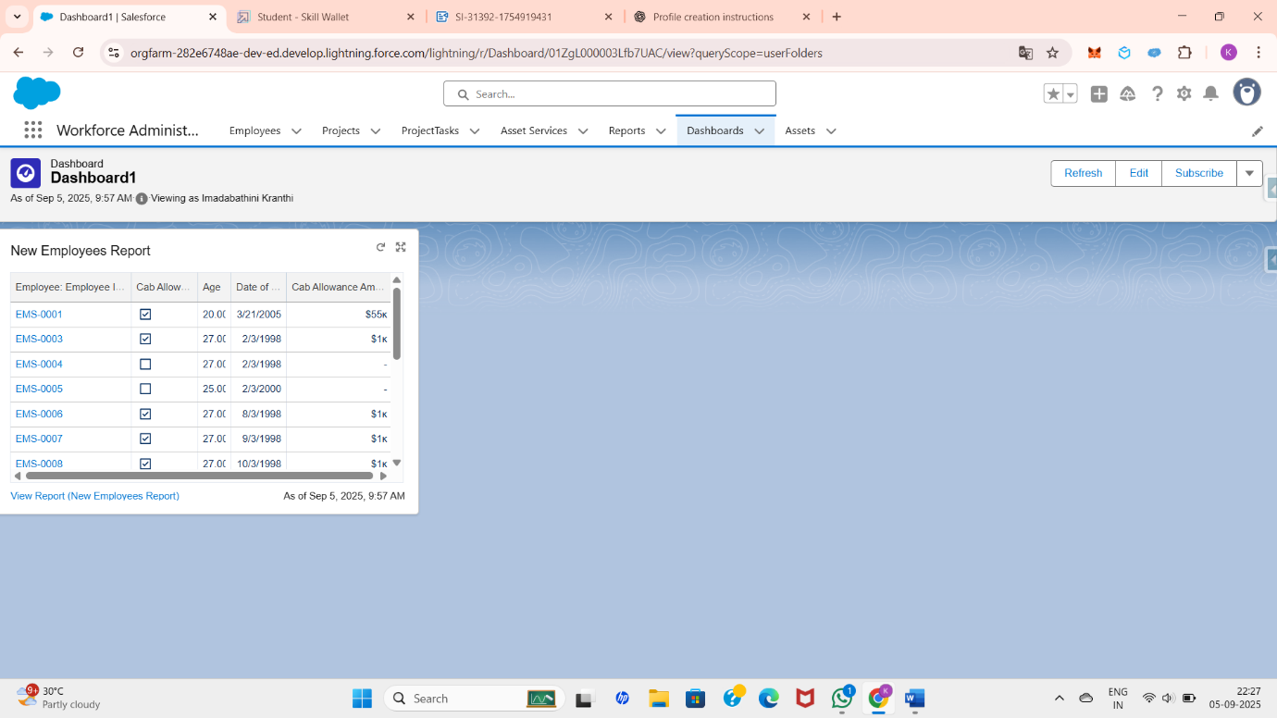

You can also create additional dashboards for the reports you created.

  2.8 Approval Process & Apex Trigger

**Approval Process:**

An **Approval Process** in Salesforce automates how records are approved within the organization. It defines a **sequence of steps** a record must go through to get approved and who needs to approve it.

**Creation of Approval Process:**

To create an approval process, first create a custom object called Leave with fields such as Name of Employee, No. of Days, Subject, Description, and Status, and also create a tab for this object. Then, go to Setup, type Approval Processes in the Quick Find box, and select it. In the Manage Approval Processes For list, choose Leave. Next, click on Create New Approval Process and select Use Jump Start Wizard to quickly configure and set up the approval process.

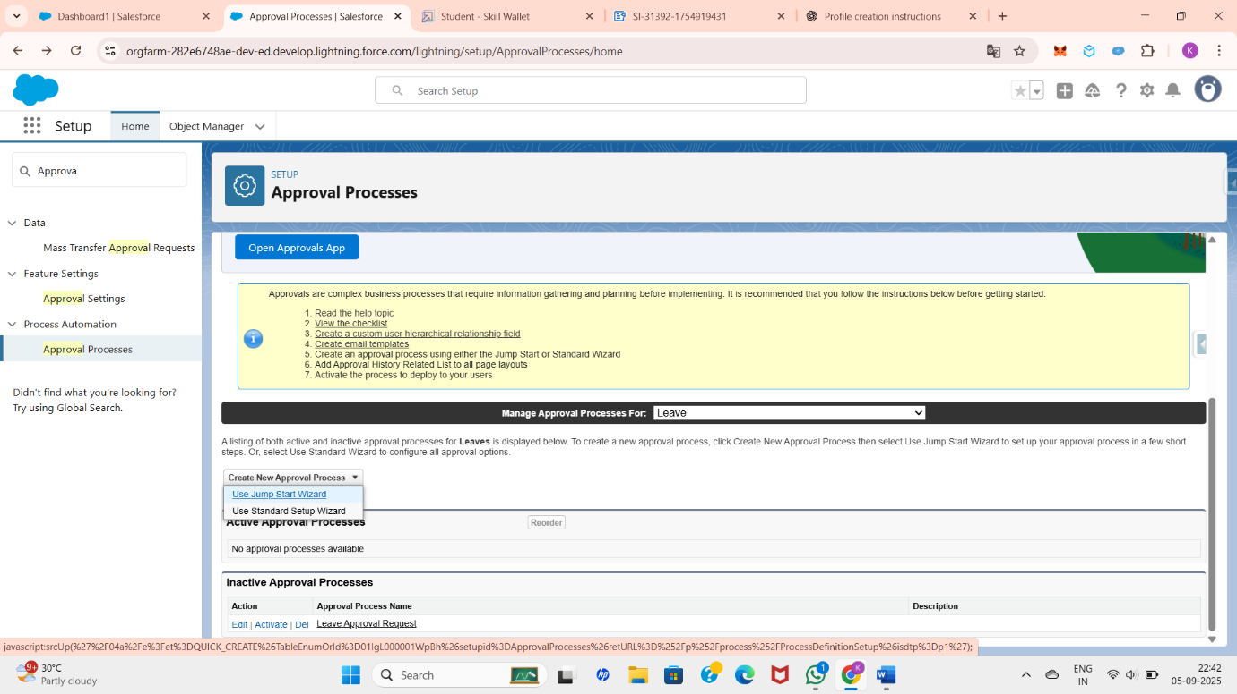

On the next page, provide a name for the approval process; a unique name will be generated automatically. Leave the Approval Assignment Email Template field blank. In the section Add the “Submit for Approval” button and Approval History related list to all Leave page layouts, keep this option selected. For the field Use Approver Field of Leave Owner, leave it unchecked. In the Select Approver field, choose Automatically assign to approver(s) and select the user with the Manager role as the approver. Click Save, and then click on View Approval Process Detail Page to review the configuration.

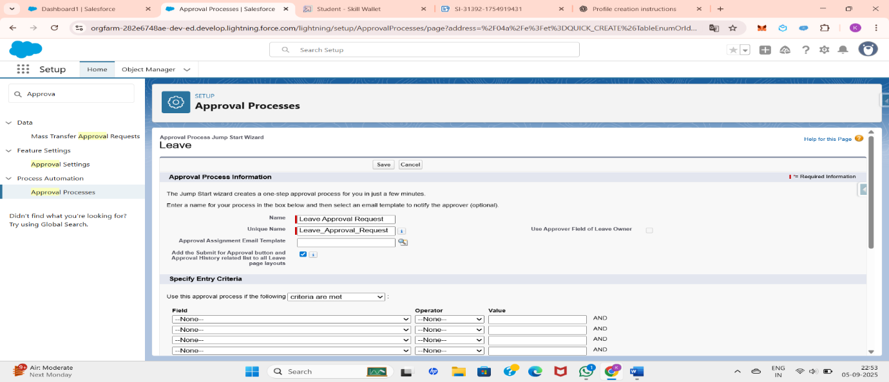

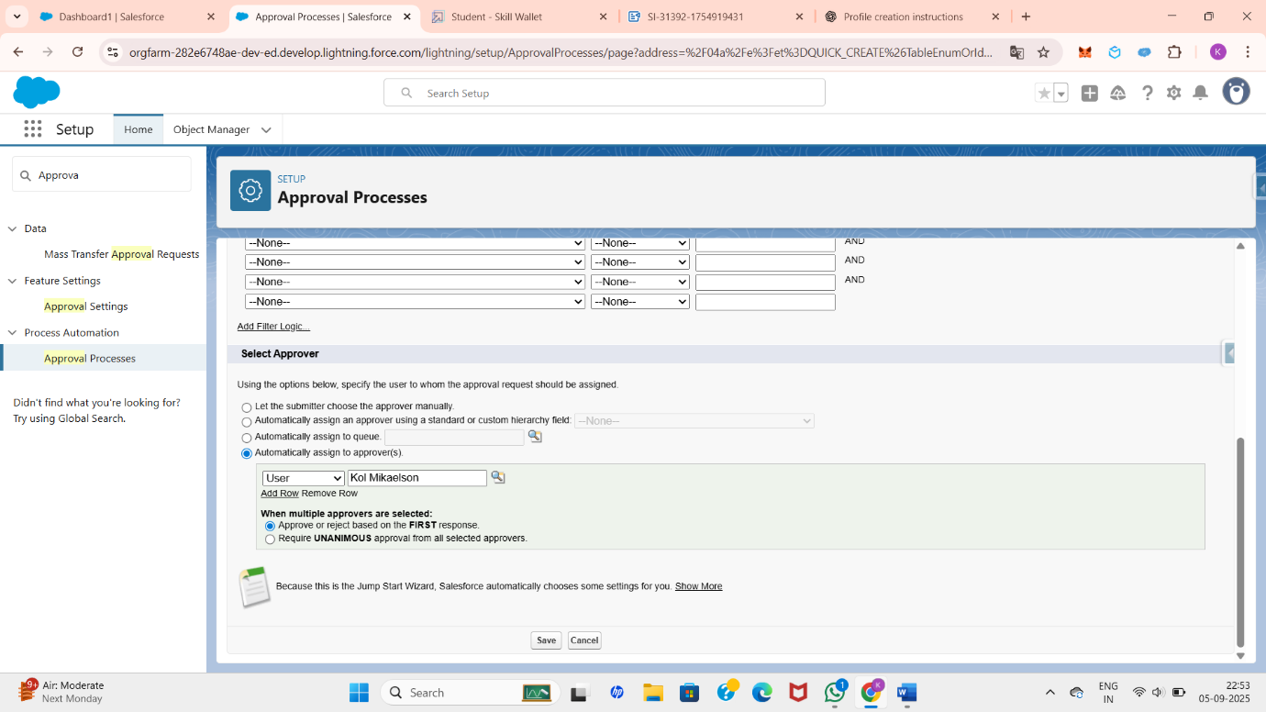Under initial submission action click on add new and then select field update. Give name as “Approval Status to Submitted”.

Select Status for the field to update.  
Under specify new field value select “A specific value” and select submitted and click Save.

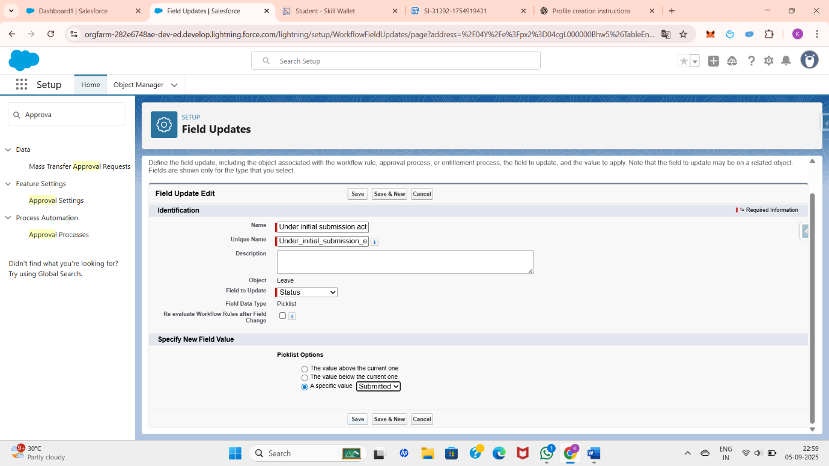

While you are still on Leave Approval Request detail page,

Under approval steps click the new approval step.

Give the name as “Approval from HR” and click on next.

Under specify step criteria select “Enter this step if the following (Criteria are met)”,

Select field : “Leave: No. of Days”,

Operator : equals, Value : 5, Click next. Under select approver : select Automatically assign to approver(s) and for users select the name of the user with the HR role. Click on Save.No, I'll do this later. Take me to the approval process detail page to review what I've just created and click Go.

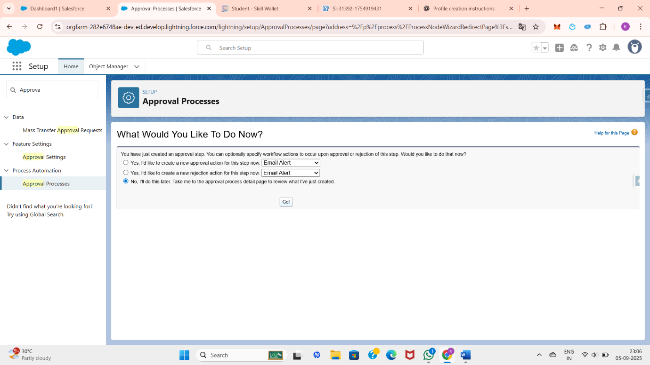

Under initial submission action click on add new and then select field update. Give name as “Approval Status to Approved”. Select Status for the field to update. Under specify new field value select “A specific value” and select Approved and click Save.

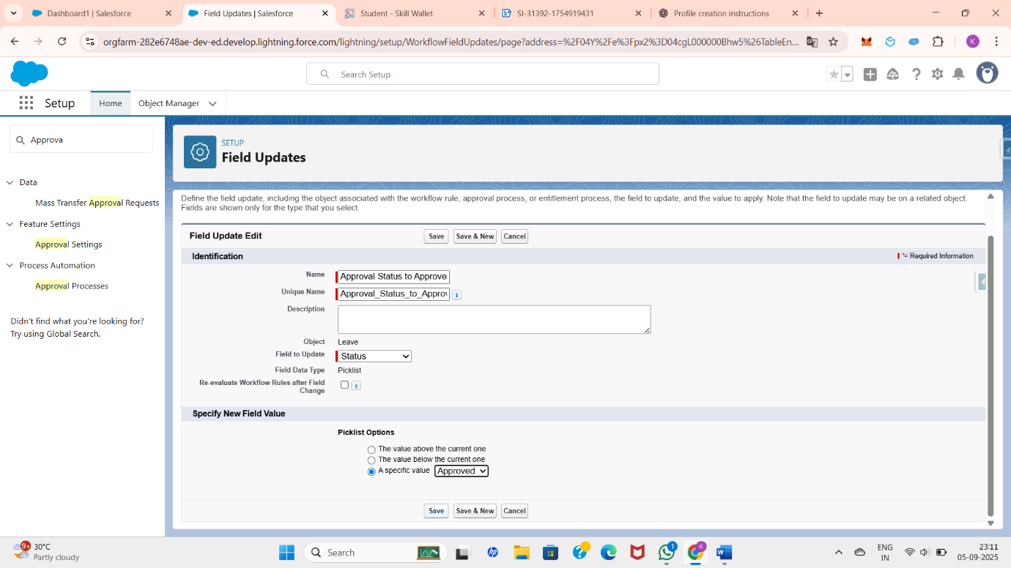

Under initial submission action click on add new and then select field update.Give name as “Approval Status to Rejected”.Select Status for the field to update. Under specify new field value select “A specific value” and select Rejected and click Save.

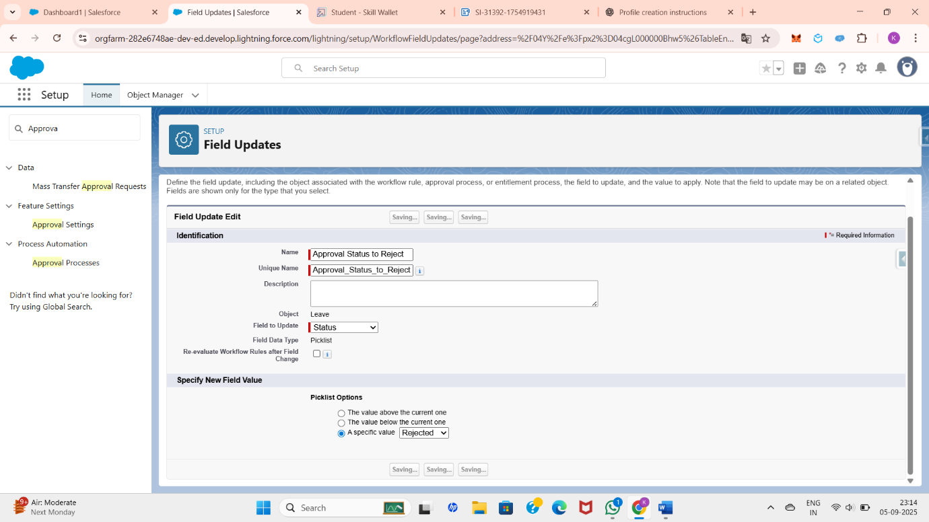

The approval process has been created successfully. Once you check and activate it, the process will run.

**Apex Trigger:**

Apex Trigger is a piece of Apex code that automatically executes before or after specific events occur on a Salesforce record, such as insert, update, delete, merge, upsert, or undelete. Triggers are used to perform custom actions like updating related records, enforcing business rules, creating tasks, or sending notifications without requiring manual intervention.

There are two main types of triggers:

* **Before Triggers** – Used to validate or update record values before they are saved to the database.
* **After Triggers** – Used to perform actions that depend on the record being saved to the database, such as updating related objects or sending emails.

I am using Apex to prevent duplicate employee names from being saved in the data.

**Creating an Apex Trigger:**

Click on gear icon and click on developer console.Click on the file, then click on New , select Apex Trigger.Give the Apex Trigger name as “EmpInsert”, and select “Employee__c” from the dropdown for sObject. click on submit and write the code .

**Apex code:**

**trigger EmpInsert on Employee__c (before insert) {**

**for(Employee__c pass : Trigger.New){**

**List<Employee__c> mynew = [SELECT Id, Name FROM Employee__c WHERE Employee_Name__c =: pass.Employee_Name__c];**

**if(mynew.size() > 0){**

**pass.Name.addError('Employee with same name is existing');**

**}**

**}**

**}**

**Testing the Apex Trigger:**

If we try to create a record with the existing Employee Name say “Kranthi” you’ll face the error while saving the record saying “Employee with same name is existing”.

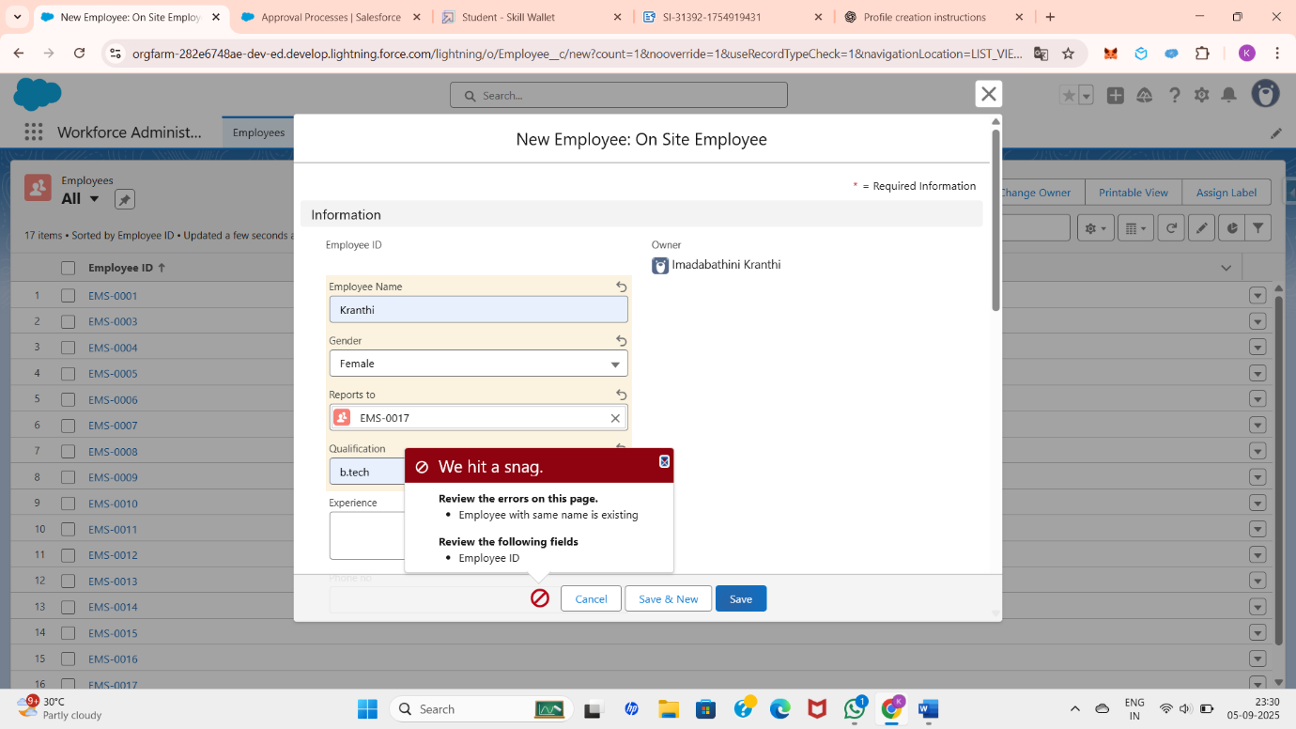

**3.UI/UX Development & Customization**

**UI/UX Development:**

The **User Interface (UI) and User Experience (UX)** play a vital role in ensuring that HR, Managers, and Employees can easily interact with the Workforce Administration System in Salesforce. A well-structured and intuitive interface improves productivity, reduces training efforts, and makes the system user-friendly. The customization was done using Salesforce’s **Lightning Experience, Page Layouts, Record Types, and Lightning App Builder** to deliver a role-based and streamlined user journey.

 3.1 Page Layouts & Field Customization

**Page Layout:**

**Page Layouts** control the **organization and visibility of fields, related lists, buttons, and sections** on a record’s detail and edit pages. They define what users see when they open a record and how they interact with it.

In your Workforce Administration Solution project, you created two page layouts:

* **On-site Employee Layout** – This layout may include fields specific to employees working at the office, such as *Work Location, Shift Timing, Attendance Details,* etc.
* **Remote Employee Layout** – This layout may include fields relevant to employees working remotely, such as *Home Address, Work-from-Home Tools, Internet Availability,* etc.

By creating multiple page layouts, you can ensure that each type of employee record displays only the fields and sections relevant to their role or work style. This improves usability, reduces clutter, and helps maintain data accuracy.

**Field Customization:**

**Field customization** allows administrators to tailor objects in Salesforce by creating, modifying, or deleting fields to capture the exact information required by the business. It ensures that data stored in Salesforce matches the organization’s needs.

There are different types of custom fields that can be created, such as **Text, Number, Date, Picklist, Checkbox, Formula, Lookup Relationship,** and **Master-Detail Relationship**. Each field type is designed to store specific kinds of information.

In the Workforce Administration Solution project, for example, you might customize the **Employee object** with fields like:

* Employee ID (Auto Number)
* Department (Picklist)
* Date of Joining (Date)
* Work Mode (Picklist: On-site/Remote)
* Status

Field customization improves data quality, makes record entry easier, and ensures reports and dashboards are meaningful.

  3.2 Record Types for Business Processes

**Record Types for business Processes:**

In Salesforce, **Record Types** are not only used to display different **page layouts** but also to support different **business processes** within the same object. A **business process** defines the stages and picklist values available for a specific type of record, ensuring that workflows match the needs of different departments or user groups.

For example:

* In a **Leave Management Process**, you can have one record type for Casual Leave and another for Sick Leave, each with different approval paths and status values.
* In a **Sales Process**, one record type might be used for Domestic Sales with its own set of opportunity stages, while another could be for International Sales with a different set of stages.

In my Workforce Administration Solution project, the record types I created (On-site Employee and Remote Employee) can be associated with different business processes:

* The **On-site Employee Record Type** could support processes like Employee personal details, login and logout details, cab allowance, and Asset Allocation.
* The **Remote Employee Record Type** could support processes like Work-from-Home Request, wifi allowances , and Remote Task Assignments.

By aligning record types with business processes, you ensure that each category of record follows the correct workflow, displays only relevant picklist values, and provides a user-friendly experience.

 3.3 Lightning Pages & App Customization

In Salesforce, **Lightning Pages** are customizable user interface pages created using the Lightning App Builder. They allow administrators to design and configure the layout and components displayed to users without needing code. Lightning Pages provide flexibility by enabling different views and experiences for various profiles or record types.

Types of Lightning Pages include:

* **App Page** – Used to create a custom home page for an app with dashboards, reports, and quick access to objects.

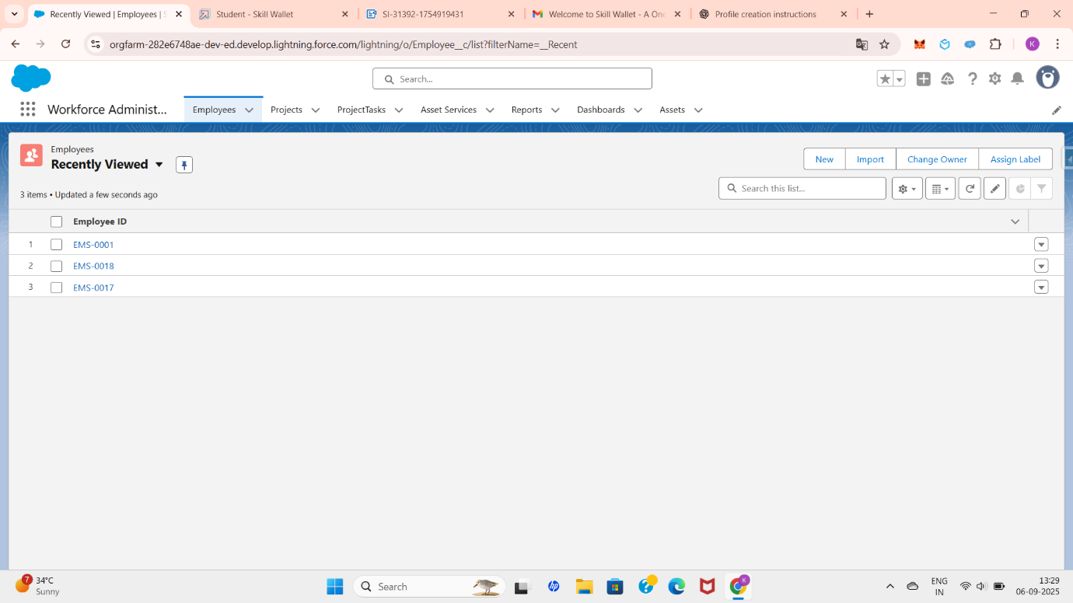

* **Home Page** – Provides a personalized view for users, showing key metrics, recent records, and tasks.
* **Record Page** – Displays detailed information about a specific record (e.g., Employee record), with customized layouts and components.

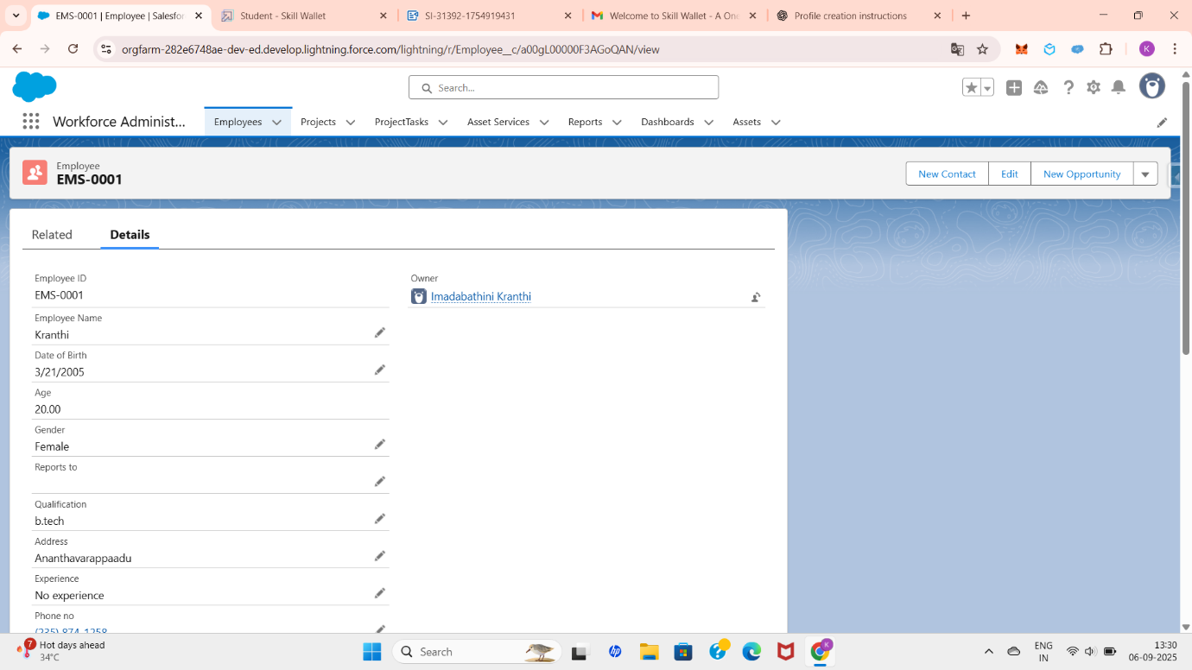

**App Customization** refers to tailoring Salesforce apps to meet business requirements. It includes:

* Adding or modifying **tabs, objects, and components** within the app.
* Assigning **navigation items** (like Employee, Assets, Projects) to the app.
* Customizing **page layouts, record types, and Lightning pages** to provide the right data to the right users.
* Enhancing user experience with **Dashboards, Reports, and Chatter**.

In your Workforce Administration Solution project, Lightning Pages and App Customization ensure that employees, managers, and administrators have intuitive dashboards, record views, and navigation tailored to their specific roles and needs.

  3.4 Chatter & Collaboration Features

**Chatter:**

Chatter  is Salesforce’s built-in enterprise social collaboration tool that helps users connect, share information, and work together more efficiently. It enables employees across the organization to collaborate in real time, reducing the need for lengthy emails or meetings.

Key **Chatter Features** include:

* **Posts and Comments** – Users can post updates, share files, and tag colleagues to keep everyone informed.
* **Chatter Groups** – Public or private groups can be created for teams, projects, or departments to streamline discussions.
* **Feeds** – Each record (such as Employee or Project) can have its own Chatter feed, allowing collaboration directly on the record.
* **Notifications** – Users receive alerts for mentions, comments, or updates, ensuring they stay engaged.
* **File Sharing** – Documents, images, and other files can be uploaded and discussed in Chatter.

**Collaboration Features:**

In Salesforce extend beyond Chatter by allowing:

* **Approvals via Chatter** – Managers can approve requests directly from a Chatter feed.
* **Integration with Records** – Team members can collaborate on employee records, projects, or leave requests in real time.
* **Enhanced Transparency** – Everyone can view updates, reducing miscommunication and increasing accountability.

In my Workforce Administration Solution project, Chatter can be used by employees to discuss projects, managers to share updates, and HR to communicate policies. For example, a **Chatter Group for Remote Employees** could help them collaborate on tasks and share resources, while an **HR Group** could be used to manage leave requests and approvals.

  3.5 Reports & Dashboards for UI Insights

**Reports and Dashboards** in Salesforce are powerful tools for analyzing data and gaining real-time insights into business processes. They help decision-makers track performance, identify trends, and take corrective actions.

**Reports:**  
A report is a list of records that meet specific criteria, displayed in rows and columns. Reports can be filtered, grouped, and customized to show the exact data users need. For example:

* **Employee Report** – Displays all employees with their departments and statuses.
* **Employees with Assets Report** – Shows which assets are assigned to which employees.
* **Employees with Projects and Tasks Report** – Tracks employee involvement across projects and their task completion.

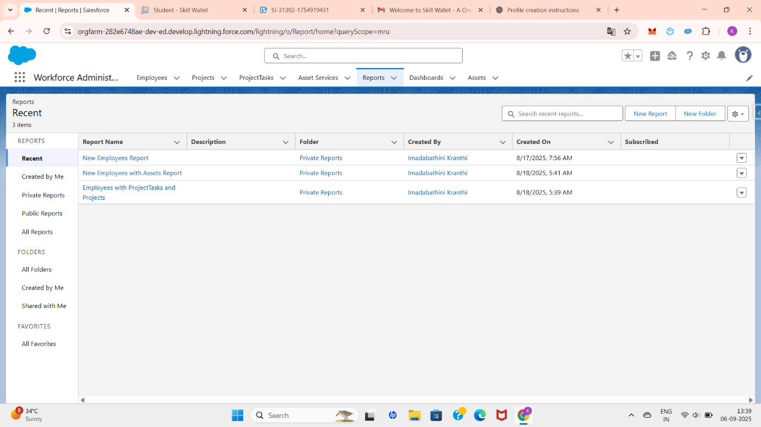

**Dashboards:**  
A dashboard is a visual representation of multiple reports. It provides users with at-a-glance insights using components like charts, tables, metrics, and gauges. Dashboards can be tailored for specific roles, such as HR managers, project leads, or administrators. For example:

* **Employee Dashboard** – Highlights the number of active vs. inactive employees.
* **Assets Dashboard** – Displays distribution of assets among employees.
* **Project & Task Dashboard** – Shows project progress and pending tasks per employee.

In this Workforce Administration Solution project, reports and dashboards provide a user-friendly way to monitor employee data, track resource allocation, and measure project performance. This ensures better decision-making, improves transparency, and enhances the overall user experience.

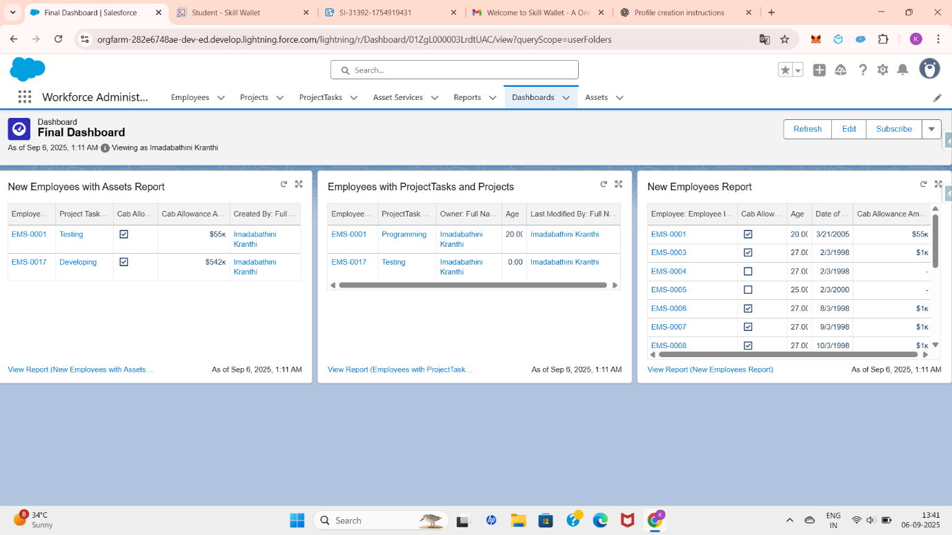

  3.6 Enhancing User Adoption

**User Adoption:**

User Adoption In Salesforce refers to how effectively end-users embrace and utilize the platform in their day-to-day activities. Even the best system can fail to deliver value if users do not actively engage with it. Therefore, enhancing user adoption is a crucial step in ensuring the success of any Salesforce implementation.

Key strategies to enhance user adoption include:

* **Training & Onboarding** – Providing hands-on training sessions, workshops, and guided tutorials helps users understand features like record creation, reports, dashboards, and Chatter.
* **Simplified UI** – Customizing page layouts, record types, and Lightning pages ensures that users only see the fields and features relevant to their roles, making the system easy to use.
* **Chatter & Collaboration** – Encouraging communication through Chatter groups and feeds increases engagement and makes users more comfortable with the platform.
* **Dashboards & Reports** – Giving users role-specific dashboards and reports provides clear insights, motivating them to use Salesforce regularly for decision-making.
* **Gamification & Recognition** – Recognizing top users, celebrating milestones, or introducing gamification can encourage adoption.
* **Continuous Feedback** – Gathering user feedback and improving the system based on their needs fosters trust and long-term adoption.

In this Workforce Administration Solution project, enhancing user adoption means ensuring that HR managers, employees, and administrators find the system intuitive and useful. For example, HR can quickly process leave approvals, employees can collaborate via Chatter, and managers can track performance through dashboards—encouraging all stakeholders to rely on the system daily.

**4.Data Migration, Testing & Security**

To ensure smooth adoption of the Workforce Administration System in Salesforce, proper **data migration, testing, and security configurations** were performed. These steps were critical to guarantee **data integrity, system reliability, and compliance with organizational security standards**.

  4.1 Data Migration

**Data Migration:**

Data Migration in Salesforce refers to the process of transferring data from an existing system (such as spreadsheets, legacy applications, or other CRMs) into Salesforce. It ensures that historical and current business data is available for users within the new system, supporting smooth operations and continuity.

The data migration process typically involves:

1. **Data Analysis & Planning** – Understanding what data needs to be migrated (e.g., employees, assets, projects) and preparing a migration strategy.
2. **Data Preparation** – Cleaning, validating, and formatting data to ensure accuracy. For example, creating an Excel/CSV file with all required fields like Employee Name, Department, Status, and Email.
3. **Mapping Data** – Mapping fields in the source data to the corresponding Salesforce object fields (e.g., Employee Name → Name field in Employee object).
4. **Data Import** – Using tools such as **Data Import Wizard** or **Data Loader** to upload records into Salesforce.
   * Data Import Wizard is user-friendly and ideal for smaller datasets.
   * Data Loader is more advanced and supports large volumes of data.
5. **Validation & Testing** – Verifying that all records have been imported correctly by checking sample records, running reports, and ensuring no errors exist.
6. **Go-Live & Monitoring** – Making the migrated data available for end-users and monitoring for issues.

Data migration ensures that employee details, project tasks, and asset allocations are successfully transferred into Salesforce. This allows managers and HR to work with accurate, centralized data right from the start.

  4.2 Testing

**Testing** in Salesforce ensures that the configurations, customizations, and developments implemented in the system work as expected and meet business requirements before going live. It helps identify and fix issues early, ensuring data accuracy, system reliability, and user satisfaction.

Key types of testing in Salesforce include:

1. **Unit Testing** – Validates individual components such as Apex triggers, classes, or workflows. Salesforce requires at least 75% code coverage through unit tests before deployment.
2. **Functional Testing** – Ensures that each feature (like record creation, approval processes, page layouts, or reports) performs according to business requirements.
3. **System Testing** – Verifies the integration of multiple components, such as employee records linked with assets and projects.
4. **User Acceptance Testing (UAT)** – Involves end-users (HR, managers, employees) testing the system to confirm it meets real-world needs and is easy to use.
5. **Regression Testing** – Ensures that new changes or customizations do not break existing functionality.
6. **Performance Testing** – Evaluates the system’s speed and scalability, especially when handling bulk data imports or complex reports.

In this **Workforce Administration Solution project**, testing would include:

* Verifying that **duplicate employee names** are blocked by the Apex trigger.
* Ensuring that **record types** (On-site and Remote Employee) display correct page layouts.
* Checking that **approval processes** correctly route leave requests to managers.
* Validating that **reports and dashboards** show accurate data.

Thorough testing guarantees that the system runs smoothly, prevents errors in production, and improves user adoption.

  4.3 Security

**Security in Salesforce** ensures that data is protected and that users have the right level of access to perform their job functions without compromising sensitive information. Salesforce provides multiple layers of security, ranging from organization-level settings to record-level access controls.

Key security features include:

➤ **Organization-Level Security**

* + Controls who can log in and from where.
  + Includes features like **IP restrictions, login hours, and password policies**.

➤ **Object-Level Security**

* + Managed through **Profiles and Permission Sets**.
  + Determines whether a user can **create, read, edit, or delete** records of a particular object (e.g., Employee, Assets, Projects).

➤ **Field-Level Security (FLS)**

* + Restricts access to specific fields within an object.
  + For example, HR can see an employee’s salary field, but managers cannot.

➤ **Record-Level Security**

* + Managed through **Organization-Wide Defaults (OWD), Role Hierarchies, Sharing Rules, and Manual Sharing**.
  + Ensures users only see records they are allowed to access.
  + For example, a manager may see all employee records in their department, while an employee can only see their own record.

➤ **Login & Identity Security**

* + Features like **Two-Factor Authentication (2FA), Single Sign-On (SSO), and Login IP Ranges** enhance login security.

In this Workforce Administration Solution project, security ensures:

* Employees can only view their own records.
* Managers can view and approve leave requests for their team.
* HR can access sensitive employee details such as salary, leave balance, and performance data.

This layered security model protects business data while still enabling collaboration and efficiency.

  4.4 Outcomes

The implementation of the **Workforce Administration Solution project** in Salesforce delivered several positive outcomes that enhanced organizational efficiency, data management, and collaboration.

**Key Outcomes:**

* **Centralized Data Management** – All employee, project, and asset data is stored in a single system, reducing redundancy and improving accuracy.
* **Streamlined Processes** – Automated approval workflows (such as leave requests) eliminated manual approvals, saving time and ensuring consistency.
* **Improved Collaboration** – With Chatter and groups, employees, managers, and HR teams were able to communicate and share updates more effectively.
* **Enhanced Visibility** – Reports and dashboards provided real-time insights into workforce performance, project status, and resource allocation.
* **Data Accuracy & Security** – Validation rules, Apex triggers (to prevent duplicate employee names), and Salesforce’s layered security model ensured reliable and secure data.
* **User-Friendly Interface** – Customized page layouts, record types (On-site and Remote Employees), and Lightning Pages improved user experience by showing only relevant information.
* **Higher User Adoption** – Training, role-based access, and intuitive dashboards encouraged employees and managers to actively use the system.

**Overall**, the project improved operational efficiency, reduced errors, and provided actionable insights to decision-makers, leading to better workforce management and productivity.

**5. Deployment, Documentation & Maintenance**

After successful development, configuration, and testing, the Salesforce-based Workforce Administration System was deployed into the production environment. Proper documentation and maintenance strategies were also implemented to ensure **long-term usability, scalability, and reliability**.

  5.1 Deployment

**Deployment** in Salesforce refers to the process of moving configurations, customizations, and developments from a **sandbox (testing environment)** to the **production environment (live system)** where end-users can access them. It ensures that all tested features, objects, workflows, and security settings are available for real-time business use.

**Steps in Deployment:**

➤ **Preparation**

* + Finalize all customizations such as objects, fields, record types, page layouts, approval processes, triggers, and dashboards.
  + Ensure thorough testing has been completed (Unit Testing, UAT, Regression Testing).
  + Take a backup of existing production data.

➤ **Deployment Tools**  
Salesforce offers different methods for deployment:

* + **Change Sets** – Used for deploying metadata between related Salesforce orgs (e.g., from Sandbox to Production).
  + **Ant Migration Tool / Salesforce CLI** – Suitable for complex deployments with large metadata sets.
  + **Managed / Unmanaged Packages** – For distributing apps or customizations across orgs.

➤ **Execution**

* + Upload and validate the Change Set or migration package.
  + Resolve any errors related to dependencies or missing components.
  + Deploy successfully to the production environment.

➤ **Post-Deployment Activities**

* + Assign profiles and permission sets to users.
  + Run sanity checks to confirm all features are working in production.
  + Conduct end-user training for smooth adoption.
  + Monitor system performance after go-live.

In this **Workforce Administration Solution project**, deployment involved moving all custom objects (Employee, Leave, Assets, Projects), record types (On-site and Remote Employees), approval processes, Apex triggers, reports, dashboards, and security settings into the production environment. This made the system fully functional for employees, managers, and HR teams to use in day-to-day operations.

  5.2 Documentation

**Documentation:**

Documentation plays a critical role in ensuring the long-term success and usability of the Workforce Administration Solution. It serves as a reference guide for administrators, developers, and end-users, helping them understand the system configuration, customization, and usage. Well-prepared documentation also supports smooth knowledge transfer, future enhancements, and troubleshooting.

**Key Elements of Documentation:**

➤ **System Configuration Documentation**

* + Details of objects created (e.g., Employee, Leave, Assets, Projects).
  + Information on fields, record types (On-site Employee, Remote Employee), and page layouts.
  + Explanation of workflows, approval processes, and automation rules.

➤ **Customization Documentation**

* + Apex triggers and classes used (e.g., duplicate employee name prevention).
  + Custom tabs, lightning pages, and dashboards created.
  + User interface modifications and record type–specific layouts.

➤ **Data Management Documentation**

* + Steps for data import/export using Data Wizard or Data Loader.
  + Data migration strategy, mapping, and validations.
  + Data backup and recovery plan.

➤ **User Documentation**

* + Step-by-step guides for creating, viewing, updating, and deleting records.
  + Instructions for generating reports and dashboards.
  + Guidelines for using Chatter groups and collaboration features.

➤ **Testing & Deployment Records**

* + Test cases executed, with results and issue resolution details.
  + Deployment checklist and procedures followed during rollout.

➤ **Maintenance & Security Documentation**

* + Procedures for regular monitoring and updates.
  + Security settings, profiles, roles, and permission sets configuration.
  + Audit logs and compliance check reports.

**In the Workforce Administration Solution project**, documentation ensures that any future administrator or developer can easily maintain and extend the system without confusion. It also provides employees with clear instructions for using the platform effectively, thereby improving user adoption and reducing training time.

  5.3 Maintenance

**Maintenance:**

Maintenance in Salesforce ensures that the system remains reliable, secure, and efficient after deployment. It involves continuous monitoring, updating, and optimizing the application to meet evolving business needs. Since Salesforce is a dynamic platform, regular maintenance is necessary to handle new features, fix issues, and adapt to organizational changes.

**Key Aspects of Maintenance:**

➤ **Monitoring and Issue Resolution**

* + Regularly monitor system performance and user activity.
  + Identify and fix bugs or errors in workflows, approval processes, or Apex triggers.
  + Check integration logs and resolve synchronization issues with external systems.

➤ **Data Maintenance**

* + Periodic data quality checks to remove duplicates, incomplete records, or outdated data.
  + Schedule regular data backups to avoid loss.
  + Ensure compliance with data security policies and regulations.

➤ **User Support and Training**

* + Provide continuous support to end-users through help desks or Chatter groups.
  + Update training materials whenever new features or customizations are introduced.
  + Collect user feedback to identify areas of improvement.

➤ **System Enhancements**

* + Implement updates based on user feedback and changing business processes.
  + Leverage Salesforce seasonal releases (Spring, Summer, Winter) to adopt new features.
  + Optimize reports, dashboards, and automation for better performance.

➤ **Security and Compliance**

* + Regularly review and update user roles, profiles, and permission sets.
  + Monitor login activity and enforce security policies like MFA (Multi-Factor Authentication).
  + Ensure that sensitive employee and organizational data is protected.

**In the Workforce Administration Solution project**, maintenance ensures smooth functioning of employee records, leave approvals, reports, dashboards, and Apex triggers. Regular system checks, timely updates, and user support help in maintaining efficiency and trust in the solution.

**6. Conclusion**

The **Workforce Administration Solution** project successfully demonstrates how Salesforce can be utilized to streamline workforce-related activities such as employee management, leave approvals, record maintenance, reporting, and collaboration. By leveraging Salesforce features like **custom objects, record types, page layouts, approval processes, reports, dashboards, and Apex triggers**, the solution provides a user-friendly and secure platform for administrators and employees alike.

Through this project, we implemented:

* **Customizations** such as On-site and Remote Employee record types, tailored page layouts, and field-level configurations.
* **Automation** with approval processes and validation using Apex triggers to prevent duplicate employee records.
* **Collaboration features** like Chatter for improved communication within teams.
* **Data management processes** including import, migration, and quality checks to ensure reliable data.
* **Reports and dashboards** for real-time insights, enabling data-driven decision-making.

The system enhances **efficiency, transparency, and user adoption** by simplifying complex HR processes into an integrated solution. It ensures **security, scalability, and maintainability**, making it adaptable to future organizational needs.

**Future Scope:**

The **Workforce Administration Solution** has been designed to meet the current requirements of workforce management, but there is significant potential for future enhancements. Some possible areas of improvement include:

➤ **Advanced Automation**

* + Implement AI-powered chatbots for employee queries.
  + Use predictive analytics to forecast employee attrition or leave trends.

➤ **Integration with External Systems**

* + Connect with payroll management systems for automated salary processing.
  + Integrate with attendance and biometric systems for accurate time tracking.

➤ **Mobile Accessibility**

* + Develop mobile-friendly Lightning pages to allow employees and managers to access records on the go.
  + Enable push notifications for approvals, leave requests, and updates.

➤ **Enhanced Reporting & Analytics**

* + Build advanced dashboards with trend analysis, KPIs, and predictive insights.
  + Incorporate AI-based recommendations for resource allocation.

➤ **Employee Self-Service Portal**

* + Allow employees to update personal details, apply for leaves, and track requests independently.
  + Enable managers to approve/reject requests directly from the portal.

➤ **Scalability & Expansion**

* + Extend the solution to manage contractors, interns, or external vendors.
  + Customize workflows for different departments like Finance, IT, and Operations.

➤ **Security Enhancements**

* + Implement stronger authentication methods (MFA, SSO).
  + Add advanced audit trails and compliance tracking for sensitive HR data.

**In conclusion,** the solution can evolve into a **comprehensive HR management platform** by integrating AI, mobile, and cross-system features, making it more powerful, scalable, and aligned with modern organizational needs.